Rotation

Definition
# Source: AI Source: Provided by: [Data Path: Persons Table -> ID Column: 1, Name_En Column: Motasem Essam] -> From: [ChatGPT] on [7/25/2026]
Rotation is a geometric transformation that turns a figure around a fixed point called the center of rotation by a specified angle.
During a rotation:
- Every point moves around the center of rotation.
- All points rotate through the same angle.
- The distance from each point to the center remains constant.
- The shape and size of the figure remain unchanged.
Therefore, a rotation is a rigid transformation, and the original and rotated figures are congruent.
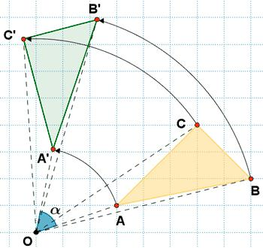
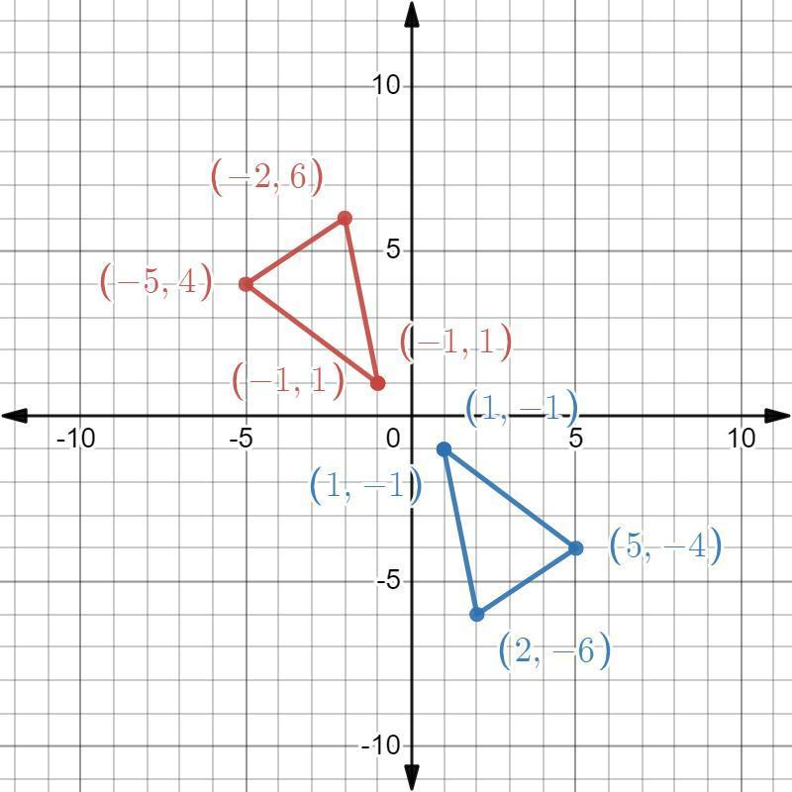
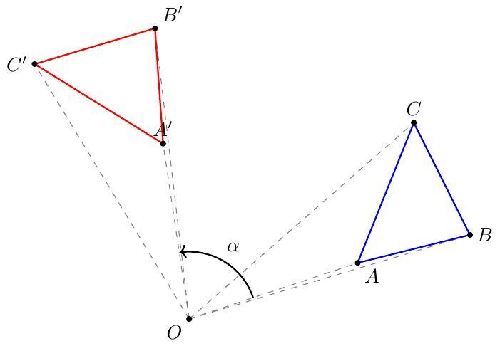
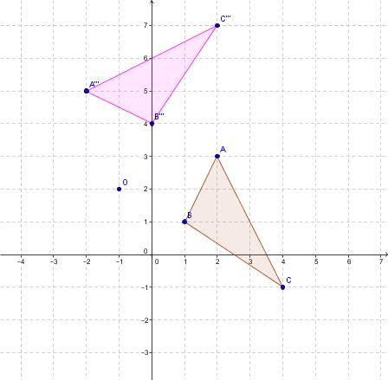
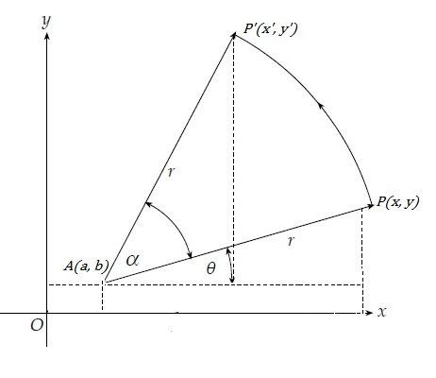
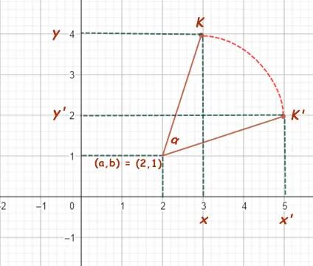

Purpose
# Source: AI Source: Provided by: [Data Path: Persons Table -> ID Column: 1, Name_En Column: Motasem Essam] -> From: [ChatGPT] on [7/25/2026]
Rotation is used to:
- Turn geometric figures around a fixed point.
- Study geometric transformations.
- Change the orientation of a figure.
- Analyze angles and symmetry.
- Transform coordinates.
- Model circular movement.
- Create geometric patterns.
- Support CAD and engineering design.
- Model movement in computer graphics and robotics.

Fundamental Idea
# Source: AI Source: Provided by: [Data Path: Persons Table -> ID Column: 1, Name_En Column: Motasem Essam] -> From: [ChatGPT] on [7/25/2026]
A rotation is determined by three main elements:
- Center of rotation
- Angle of rotation
- Direction of rotation
For example:
$$\boxed{{90}^{∘}\text{ counterclockwise}}$$
means that every point is rotated ${90}^{∘}$around the center in the counterclockwise direction.
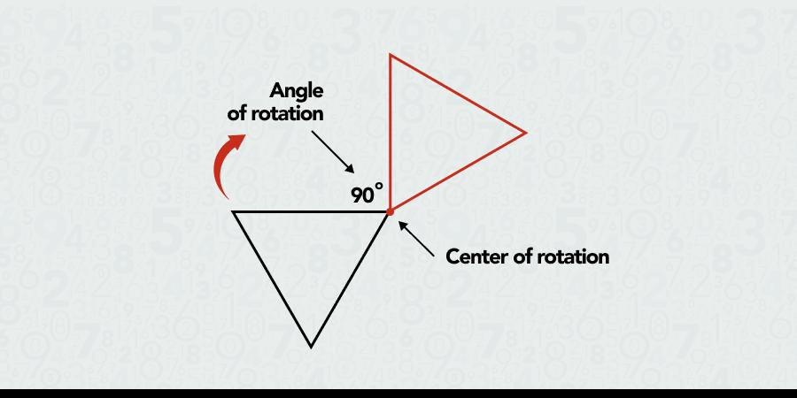
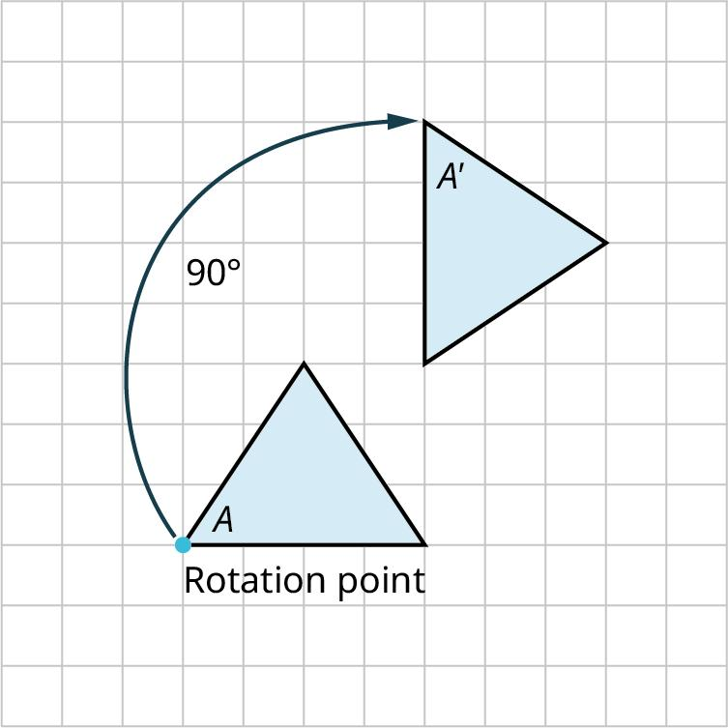
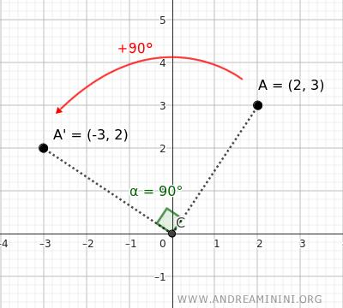
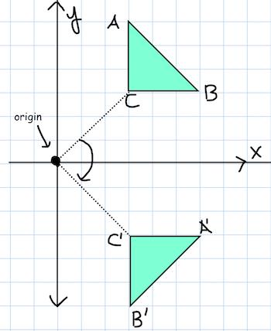
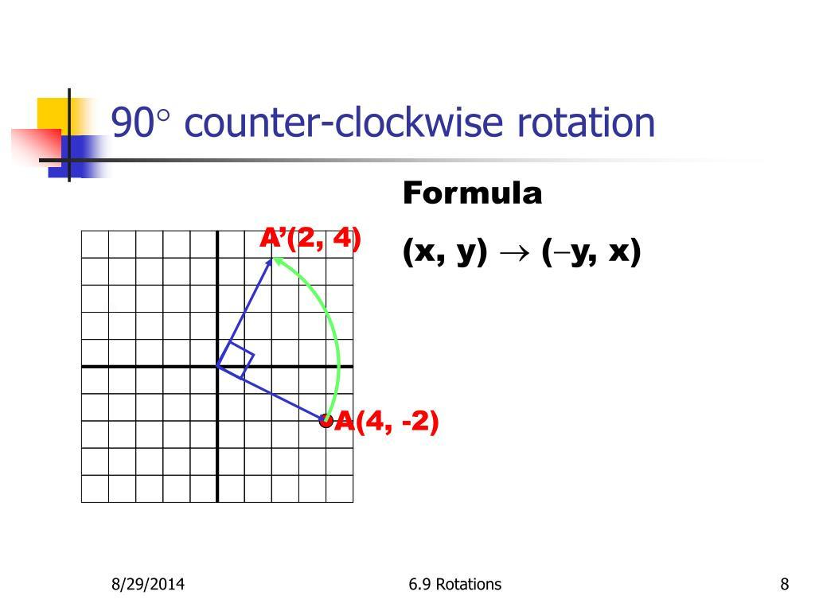
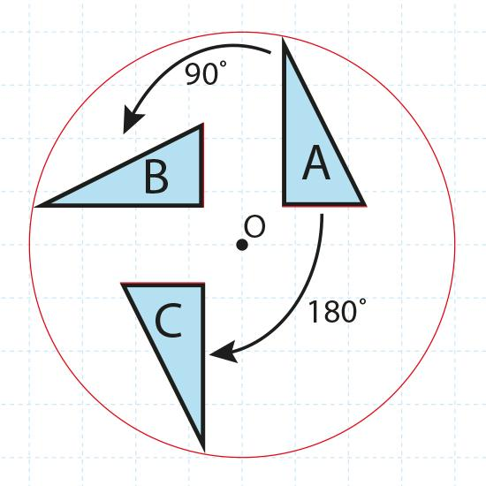

Center of Rotation
# Source: AI Source: Provided by: [Data Path: Persons Table -> ID Column: 1, Name_En Column: Motasem Essam] -> From: [ChatGPT] on [7/25/2026]
The center of rotation is the fixed point around which the figure rotates.
It is commonly represented by:
$$\boxed{O}$$
The center itself does not move.
If a point $A$ rotates around $O$ to become $A^{'}$, then:
$$\boxed{OA=OA^{'}}$$
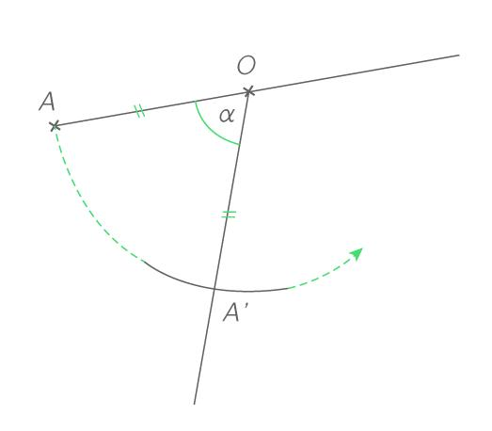
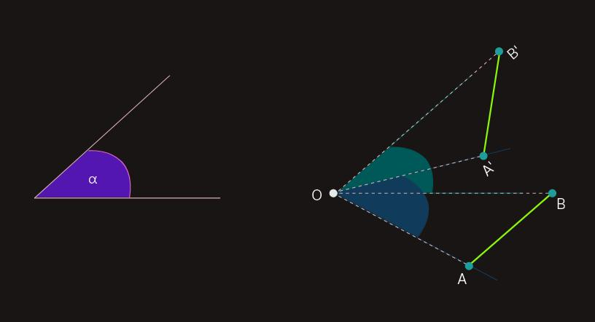
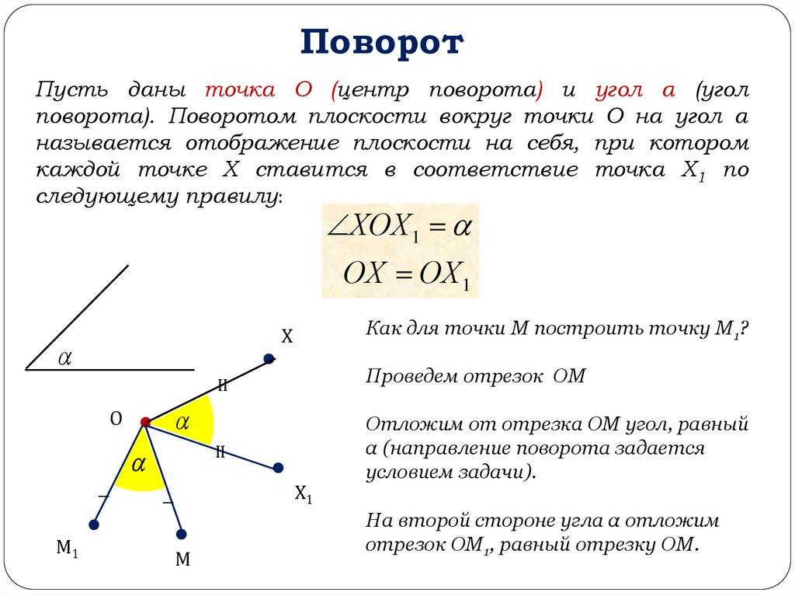

Angle of Rotation
# Source: AI Source: Provided by: [Data Path: Persons Table -> ID Column: 1, Name_En Column: Motasem Essam] -> From: [ChatGPT] on [7/25/2026]
The angle of rotation describes how far the figure turns.
Common rotation angles include:
$$\boxed{{90}^{∘}} \\ \boxed{{180}^{∘}} \\ \boxed{{270}^{∘}} \\ \boxed{{360}^{∘}}$$
A rotation of ${360}^{∘}$ returns the figure to its original position.

Direction of Rotation
# Source: AI Source: Provided by: [Data Path: Persons Table -> ID Column: 1, Name_En Column: Motasem Essam] -> From: [ChatGPT] on [7/25/2026]
There are two standard directions:
Counterclockwise
The figure rotates opposite to the direction of clock hands.
$$\boxed{+θ}$$
Clockwise
The figure rotates in the direction of clock hands.
$$\boxed{-θ}$$
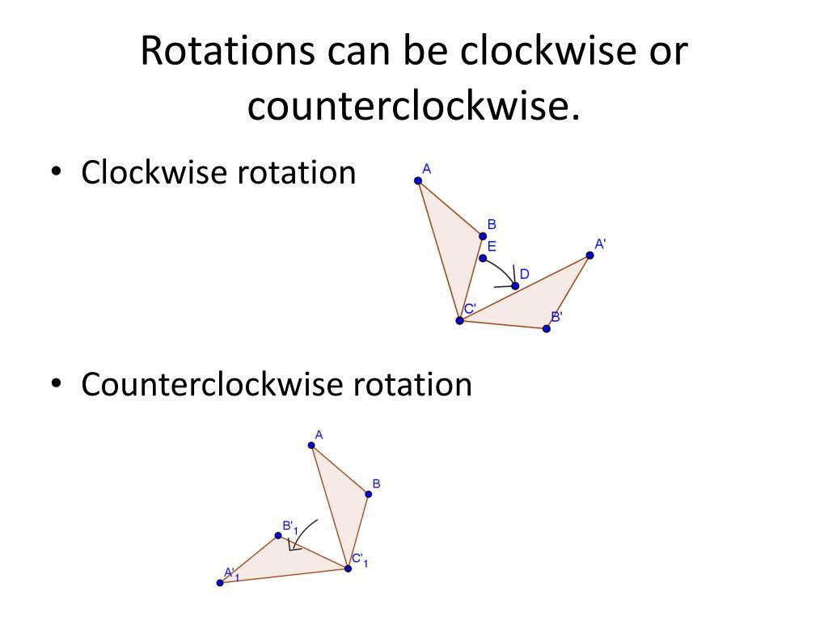
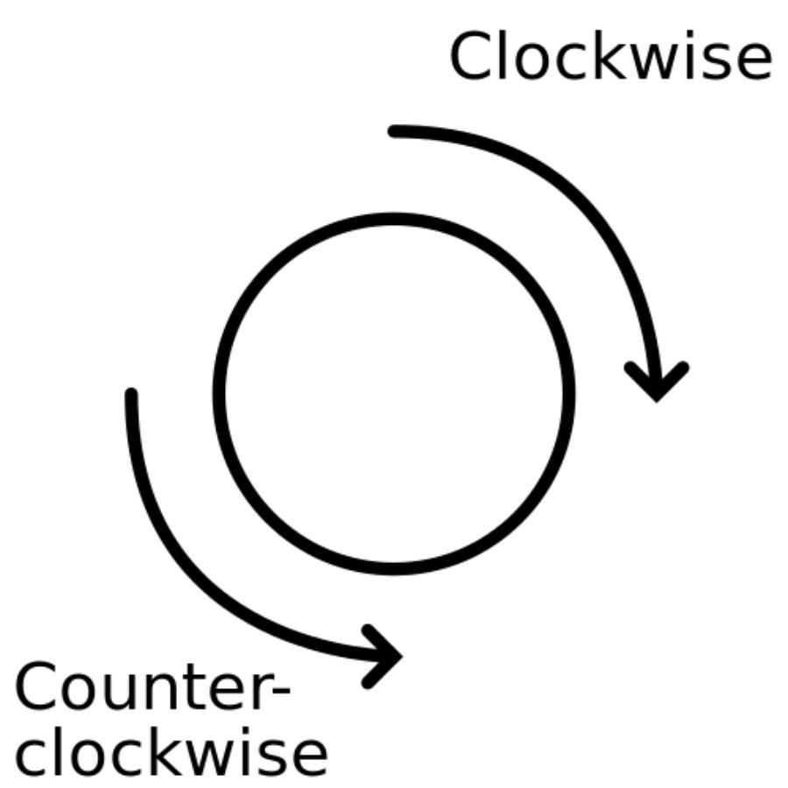
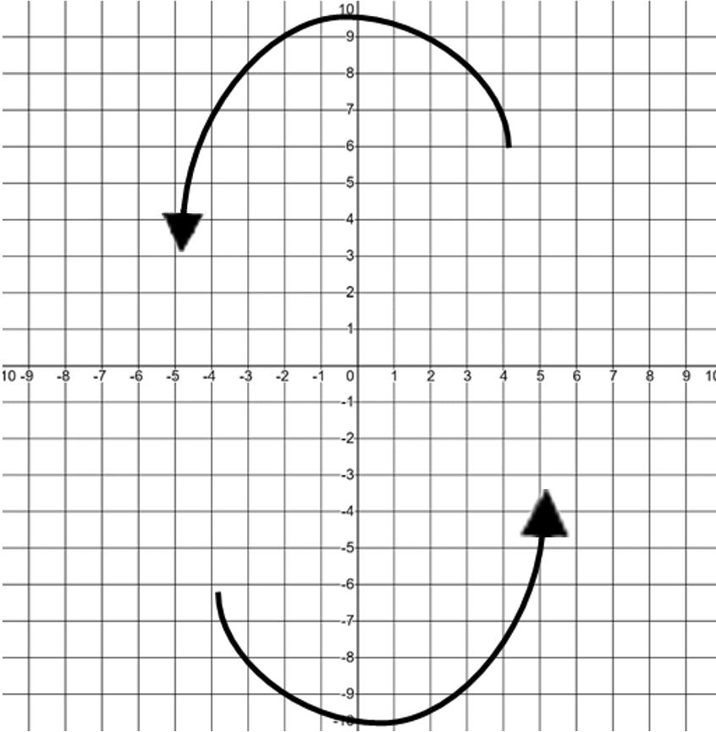
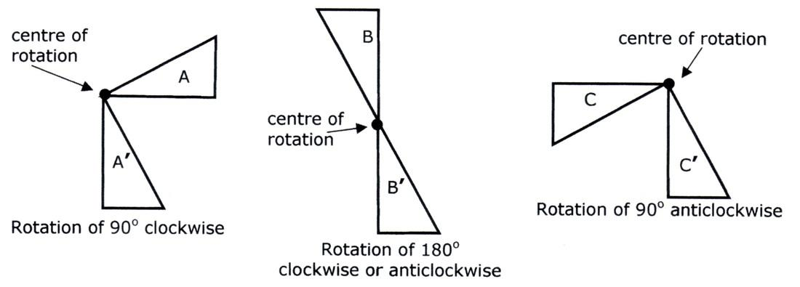
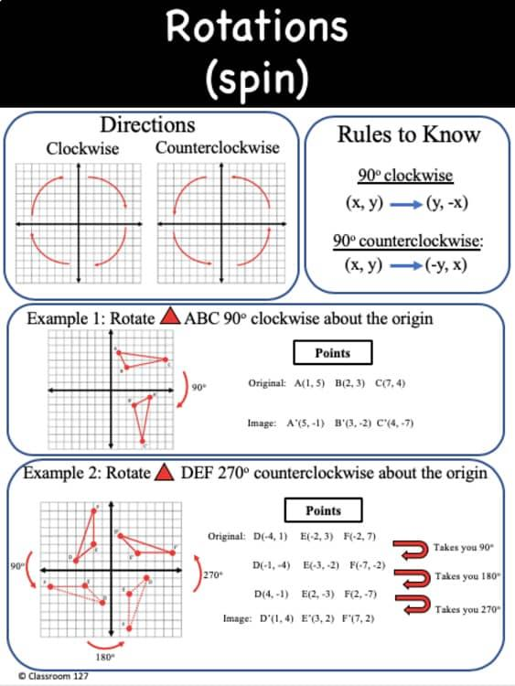
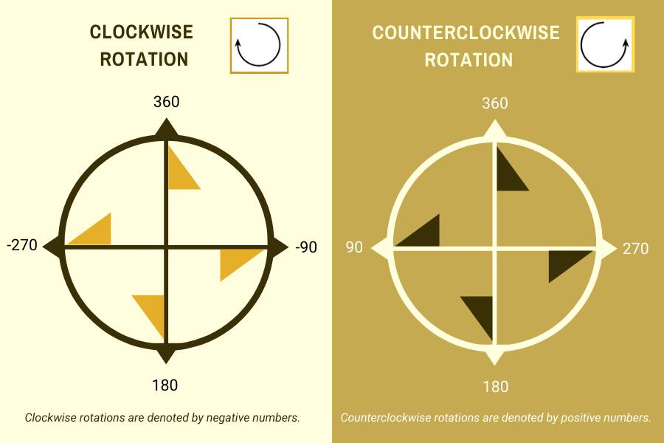

Rotation by ${90}^{∘}$
# Source: AI Source: Provided by: [Data Path: Persons Table -> ID Column: 1, Name_En Column: Motasem Essam] -> From: [ChatGPT] on [7/25/2026]
A ${90}^{∘}$ rotation turns a figure through a quarter of a full revolution.
$$\boxed{{90}^{∘}=\frac{1}{4}\left({360}^{∘}\right)}$$
For a counterclockwise rotation about the origin:
$$\boxed{\left(x , y\right)→\left(- , yx\right)}$$
For a clockwise rotation:
$$\boxed{\left(x , y\right)→\left(y , -x\right)}$$
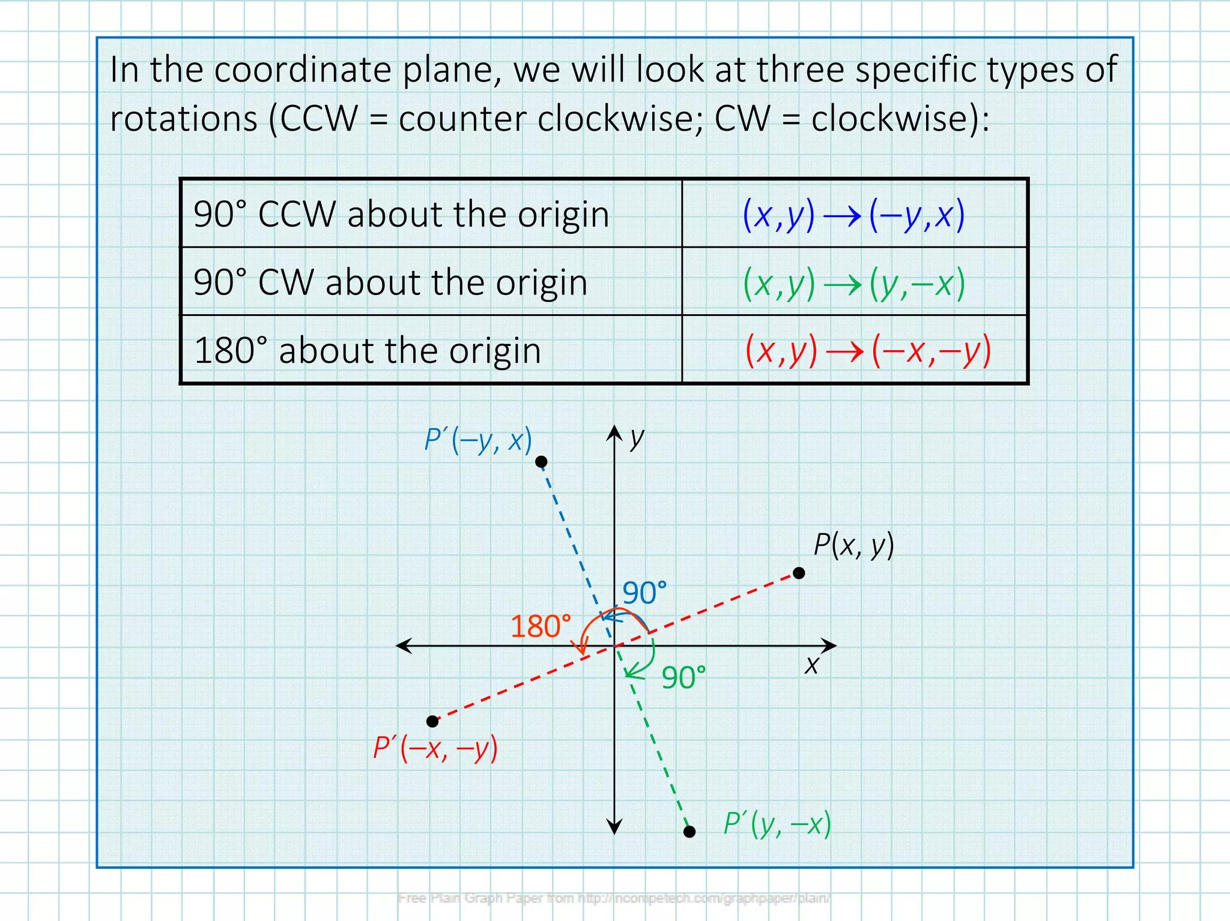
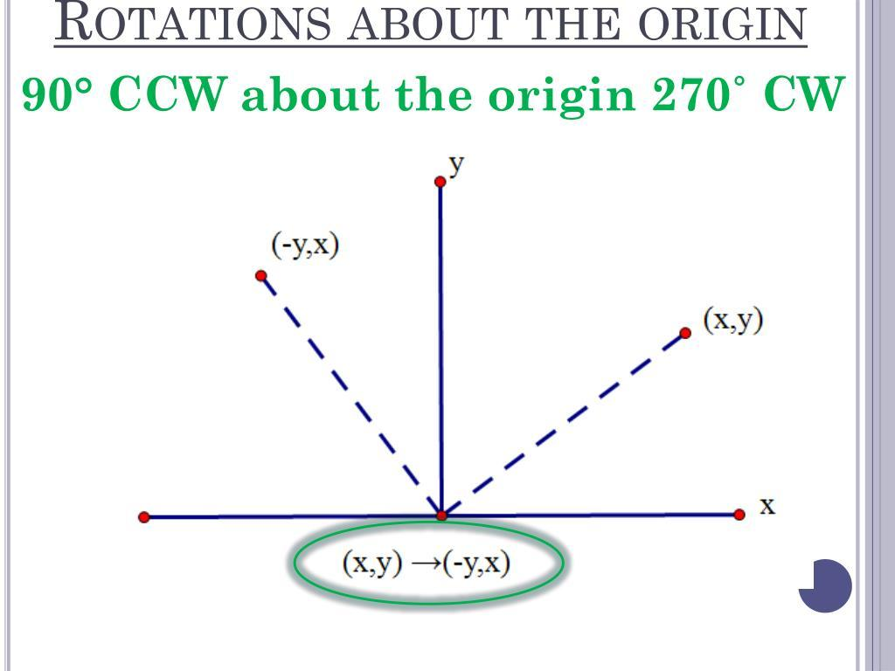
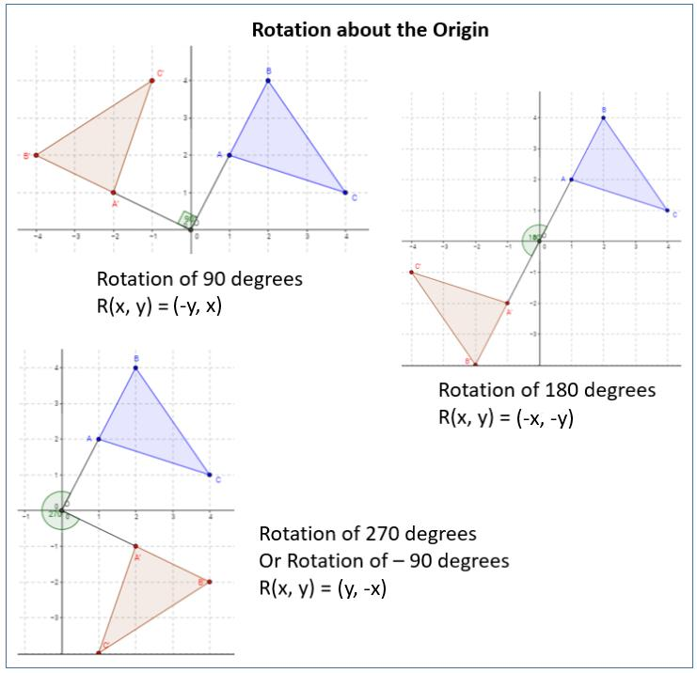
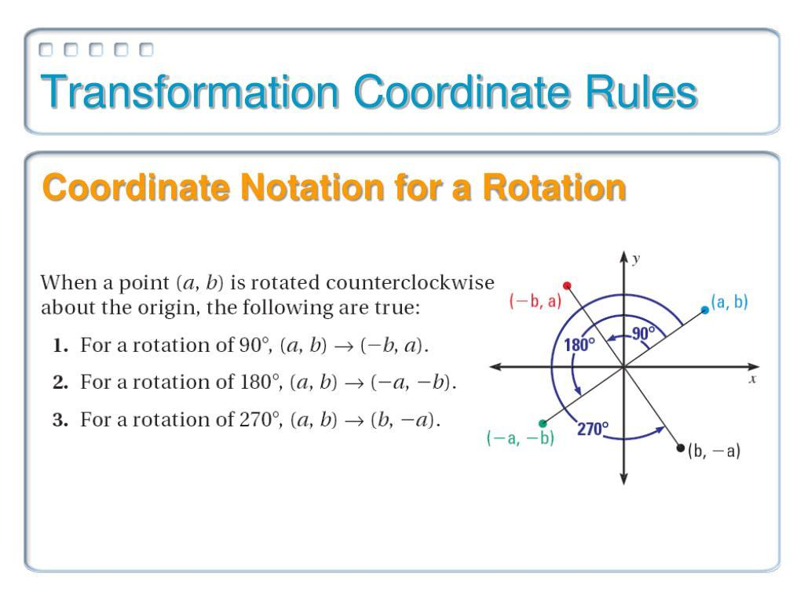

Rotation by ${180}^{∘}$
# Source: AI Source: Provided by: [Data Path: Persons Table -> ID Column: 1, Name_En Column: Motasem Essam] -> From: [ChatGPT] on [7/25/2026]
A ${180}^{∘}$ rotation is a half-turn.
$$\boxed{{180}^{∘}=\frac{1}{2}\left({360}^{∘}\right)}$$
About the origin:
$$\boxed{\left(x , y\right)→\left(- , x-y\right)}$$
A ${180}^{∘}$ rotation changes a point to the point directly opposite it across the center of rotation.
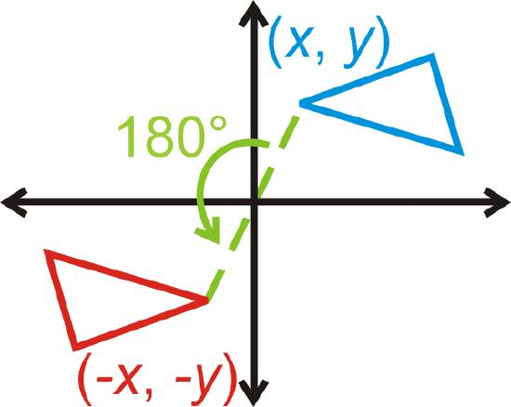
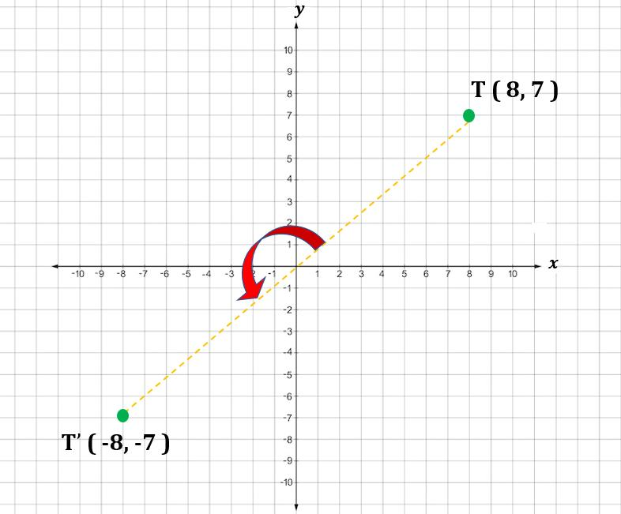
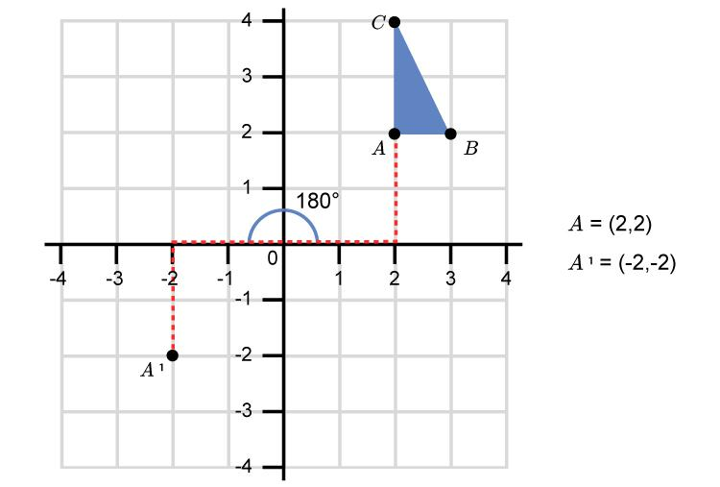
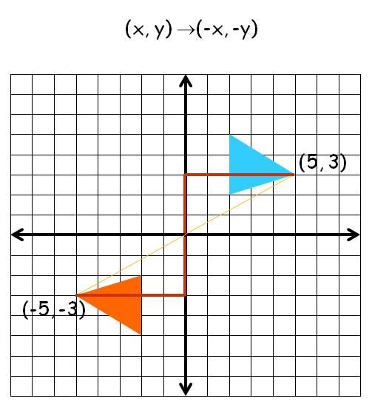
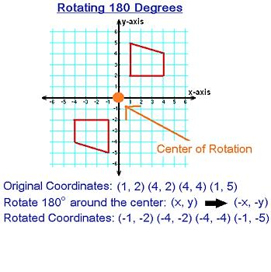

Rotation by ${270}^{∘}$
# Source: AI Source: Provided by: [Data Path: Persons Table -> ID Column: 1, Name_En Column: Motasem Essam] -> From: [ChatGPT] on [7/25/2026]
A ${270}^{∘}$ counterclockwise rotation is equivalent to a ${90}^{∘}$clockwise rotation.
The coordinate rule is:
$$\boxed{\left(x , y\right)→\left(y , -x\right)}$$
for a ${270}^{∘}$ counterclockwise rotation about the origin.
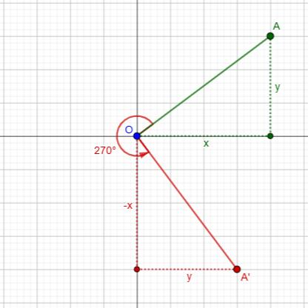
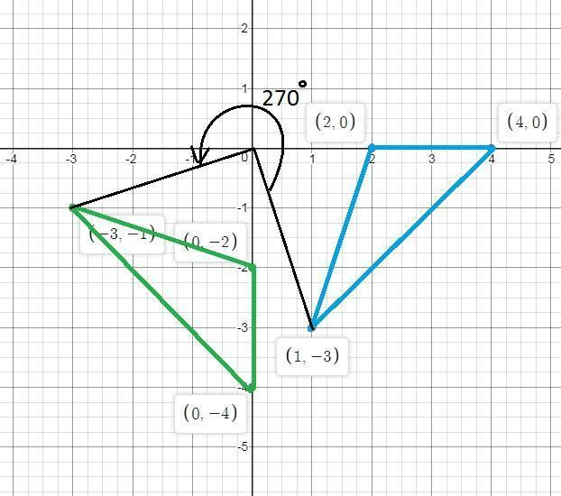
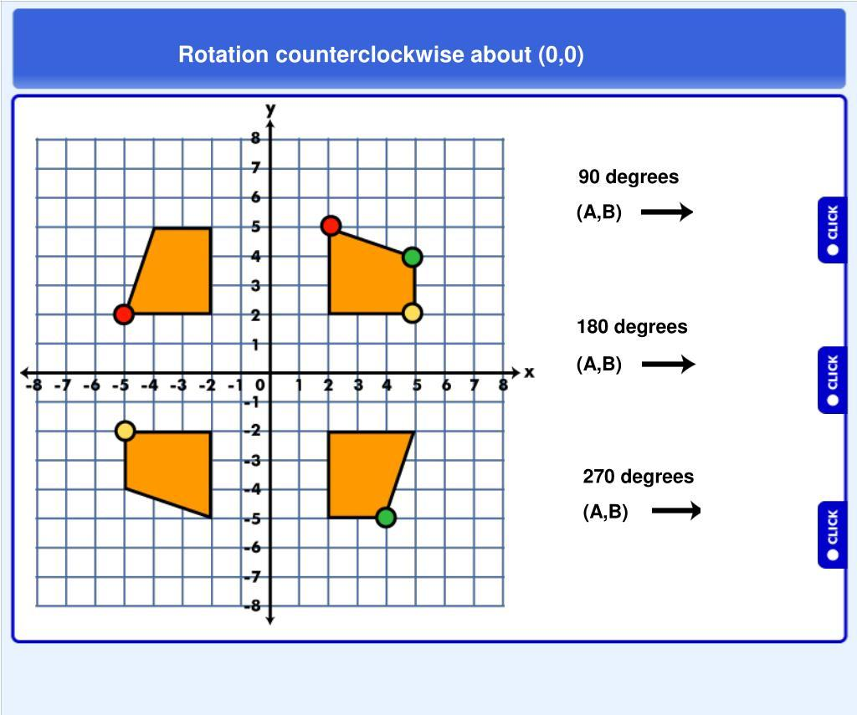
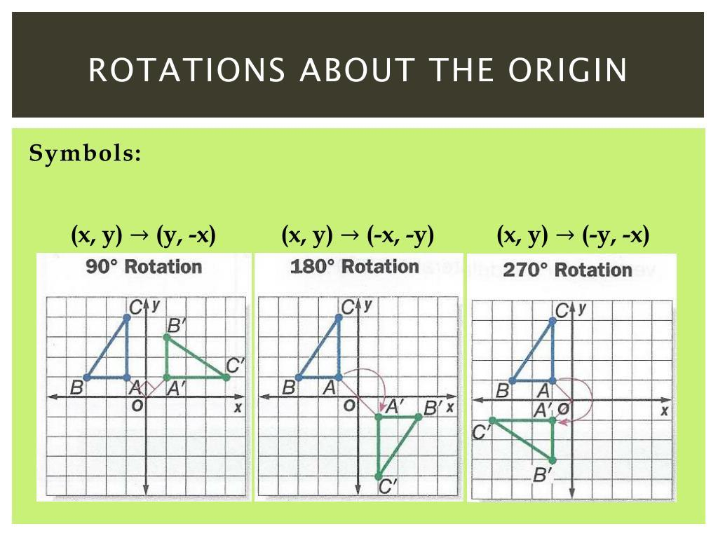
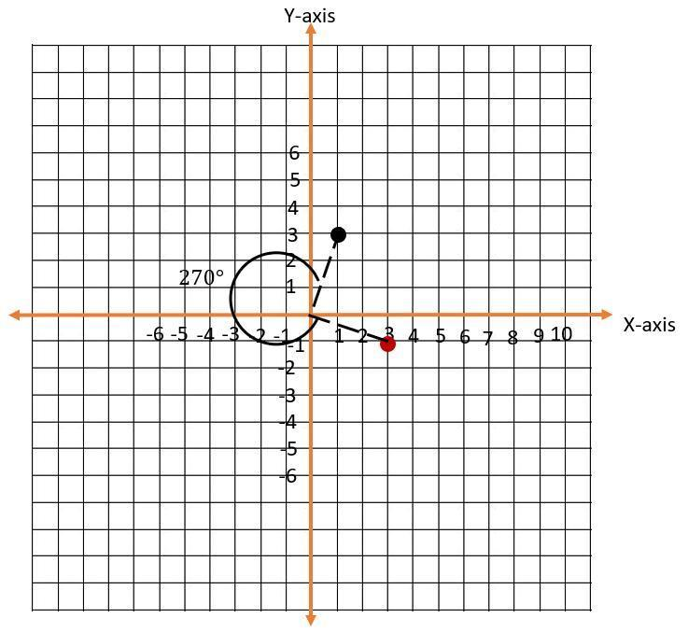

Rotation by ${360}^{∘}$
# Source: AI Source: Provided by: [Data Path: Persons Table -> ID Column: 1, Name_En Column: Motasem Essam] -> From: [ChatGPT] on [7/25/2026]
A complete rotation is:
$$\boxed{{360}^{∘}}$$
After a full rotation, every point returns to its original position.
$$\boxed{\left(x , y\right)→\left(x , y\right)}$$
Therefore, the figure is unchanged.
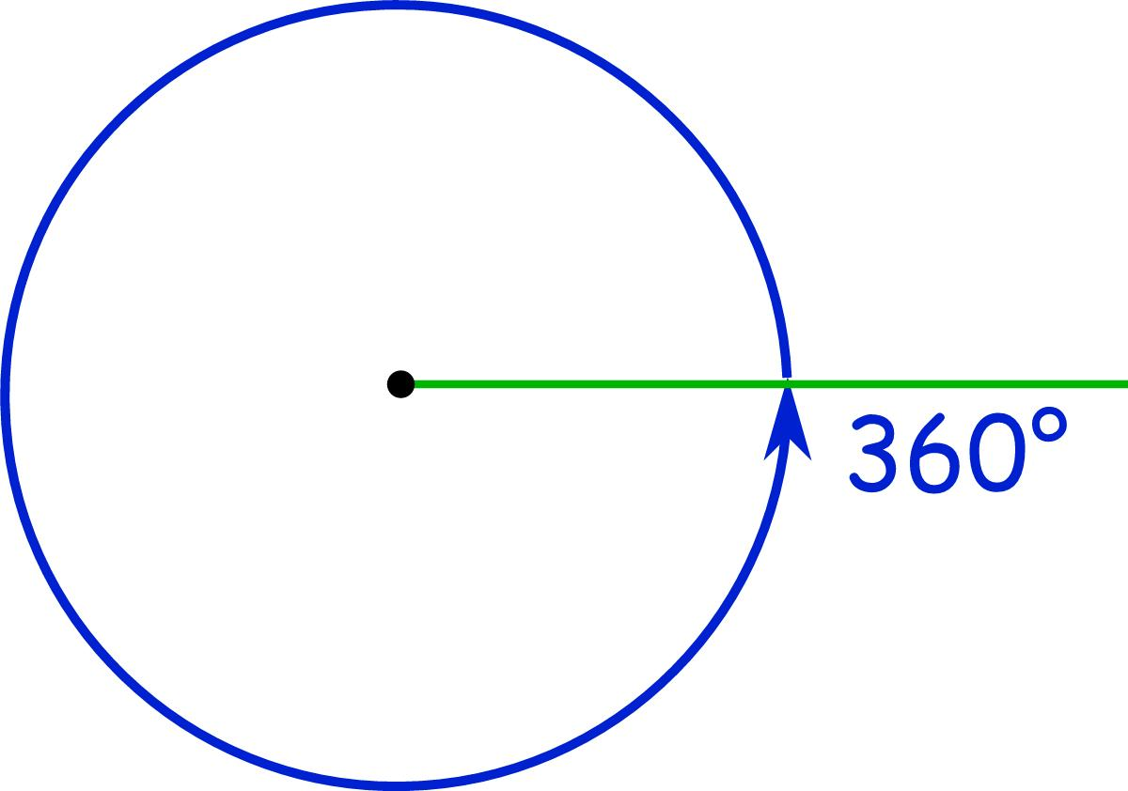
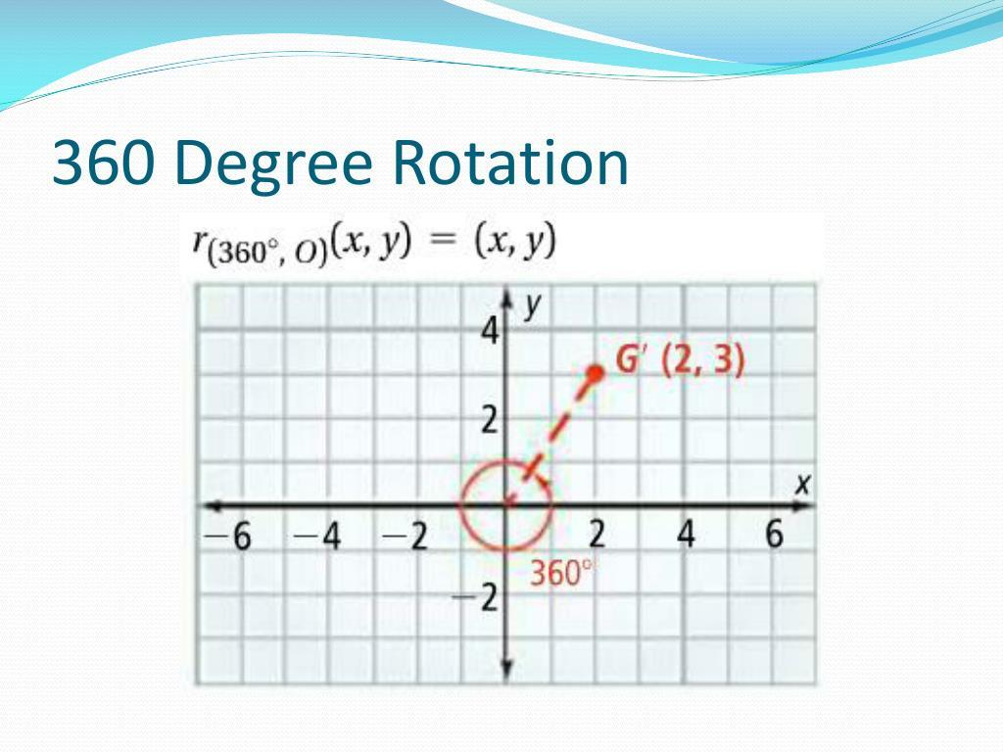
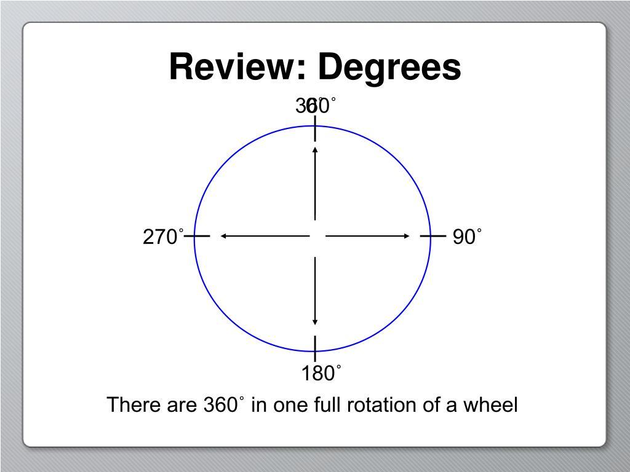
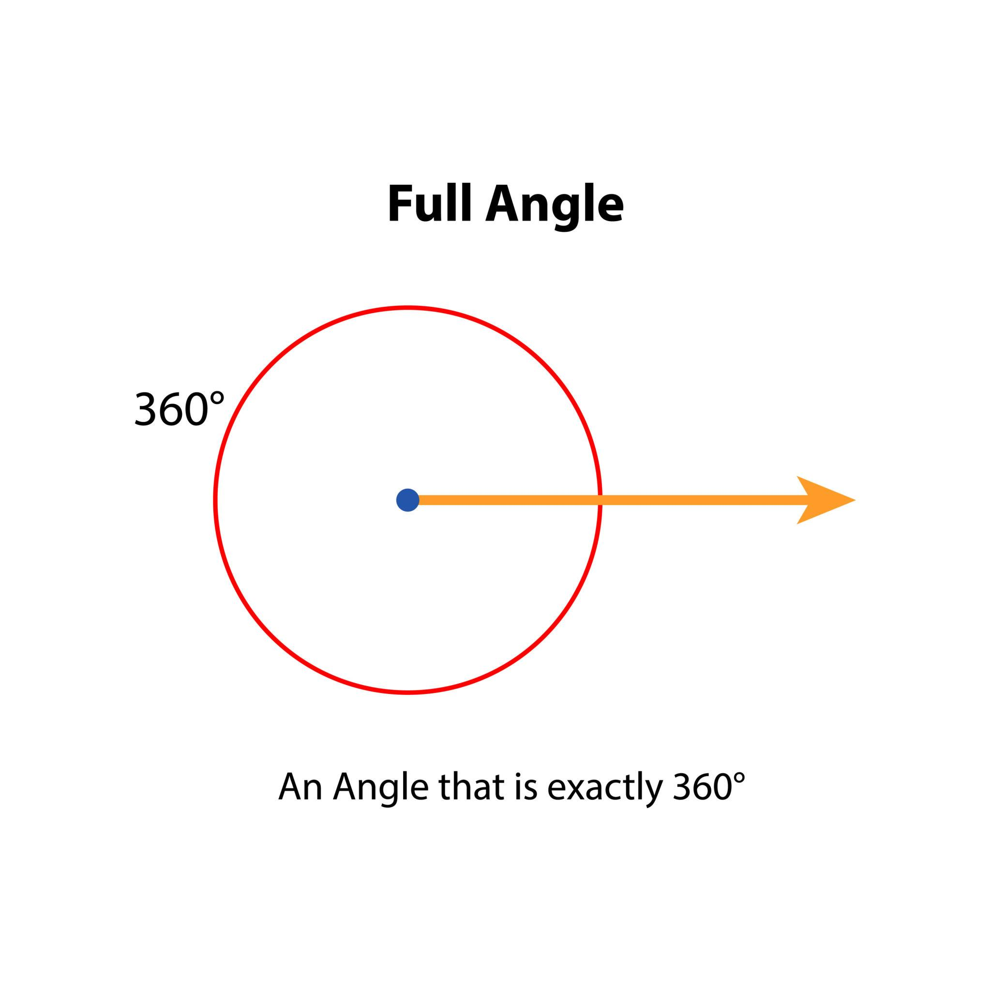

Rotation Around the Origin
# Source: AI Source: Provided by: [Data Path: Persons Table -> ID Column: 1, Name_En Column: Motasem Essam] -> From: [ChatGPT] on [7/25/2026]
The origin:
$$\boxed{O=\left(0 , 0\right)}$$
is one of the most common centers of rotation.
${90}^{∘}$ Counterclockwise
$$\boxed{\left(x , y\right)→\left(- , yx\right)}$$
$${180}^{∘}$$
$$\boxed{\left(x , y\right)→\left(- , x-y\right)}$$
${270}^{∘}$ Counterclockwise
$$\boxed{\left(x , y\right)→\left(y , -x\right)}$$
$${360}^{∘}$$
$$\boxed{\left(x , y\right)→\left(x , y\right)}$$

Example — ${90}^{∘}$ Counterclockwise
# Source: AI Source: Provided by: [Data Path: Persons Table -> ID Column: 1, Name_En Column: Motasem Essam] -> From: [ChatGPT] on [7/25/2026]
Suppose:
$$A=\left(2 , 3\right)$$
Rotate $A{ 90}^{∘}$ counterclockwise about the origin.
Use:
$$\left(x , y\right)→\left(- , yx\right)$$
Therefore:
$$A^{'}=\left(- , 32\right)$$
So:
$$\boxed{A^{'}=\left(- , 32\right)}$$

Example — ${180}^{∘}$
# Source: AI Source: Provided by: [Data Path: Persons Table -> ID Column: 1, Name_En Column: Motasem Essam] -> From: [ChatGPT] on [7/25/2026]
Suppose:
$$B=\left(4 , -2\right)$$
Rotate $B{ 180}^{∘}$ about the origin.
Use:
$$\left(x , y\right)→\left(- , x-y\right)$$
Therefore:
$$B^{'}=\left(- , 42\right) \\ \boxed{B^{'}=\left(- , 42\right)}$$

Rotation of a Triangle
# Source: AI Source: Provided by: [Data Path: Persons Table -> ID Column: 1, Name_En Column: Motasem Essam] -> From: [ChatGPT] on [7/25/2026]
Suppose a triangle has vertices:
$$A=\left(1 , 1\right) \\ B=\left(4 , 1\right) \\ C=\left(2 , 3\right)$$
Rotate the triangle ${90}^{∘}$ counterclockwise around the origin.
Using:
$$\left(x , y\right)→\left(- , yx\right)$$
we obtain:
$$A^{'}=\left(- , 11\right) \\ B^{'}=\left(- , 14\right) \\ C^{'}=\left(- , 32\right)$$
Therefore:
$$\boxed{A^{'}\left(- , 11\right), B^{'}\left(- , 14\right), C^{'}\left(- , 32\right)}$$
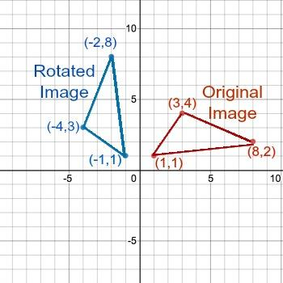
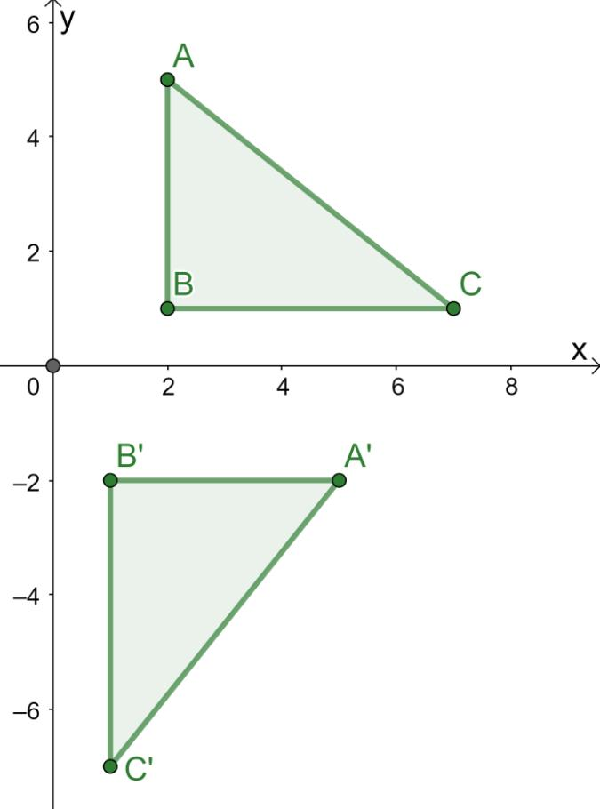
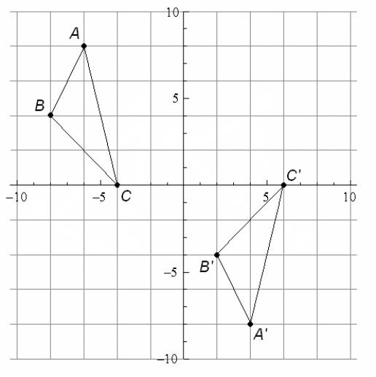
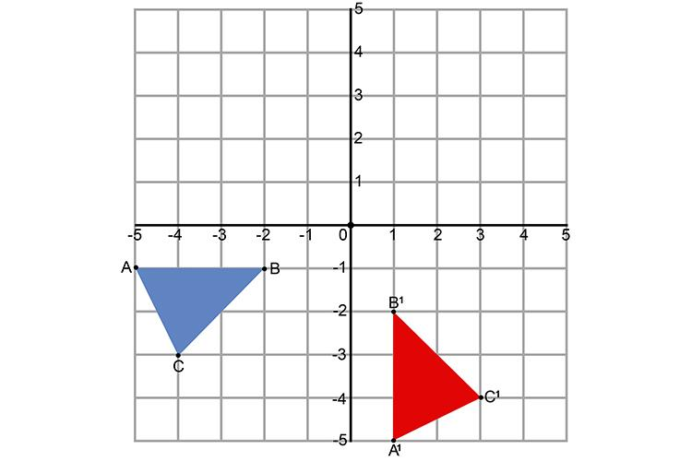
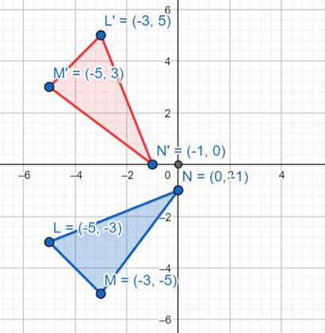

Rotation Preserves Distance
# Source: AI Source: Provided by: [Data Path: Persons Table -> ID Column: 1, Name_En Column: Motasem Essam] -> From: [ChatGPT] on [7/25/2026]
Rotation preserves the distance of every point from the center of rotation.
If $O$ is the center:
$$\boxed{OA=OA^{'}}$$
Therefore, points move along circular paths centered at $O$.
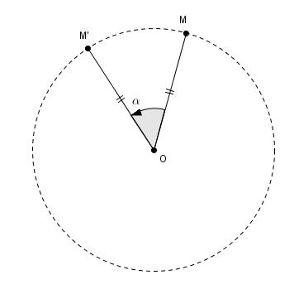
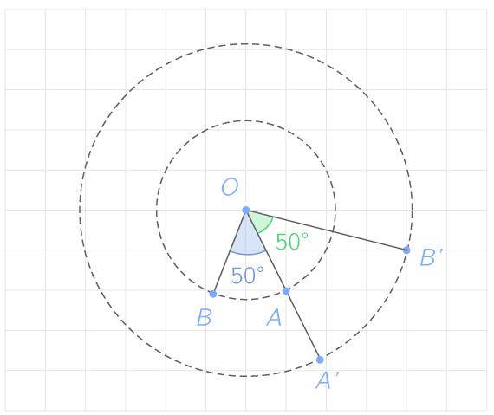

Rotation Preserves Side Lengths
# Source: AI Source: Provided by: [Data Path: Persons Table -> ID Column: 1, Name_En Column: Motasem Essam] -> From: [ChatGPT] on [7/25/2026]
Rotation does not change the length of any side.
If:
$$AB=5$$
then:
$$\boxed{A^{'}B^{'}=5}$$
Therefore:
$$\boxed{AB=A^{'}B^{'}}$$

Rotation Preserves Angles
# Source: AI Source: Provided by: [Data Path: Persons Table -> ID Column: 1, Name_En Column: Motasem Essam] -> From: [ChatGPT] on [7/25/2026]
Rotation preserves angle measures.
If:
$$∠A={60}^{∘}$$
then:
$$\boxed{∠A^{'}={60}^{∘}}$$
Therefore, the rotated figure has exactly the same angle measures as the original.

Rotation Preserves Shape
# Source: AI Source: Provided by: [Data Path: Persons Table -> ID Column: 1, Name_En Column: Motasem Essam] -> From: [ChatGPT] on [7/25/2026]
A rotation does not stretch, shrink, or distort a figure.
$$\boxed{{\text{Shape}}_{original}={\text{Shape}}_{rotated}}$$
The figure simply changes its orientation.

Rotation Preserves Size
# Source: AI Source: Provided by: [Data Path: Persons Table -> ID Column: 1, Name_En Column: Motasem Essam] -> From: [ChatGPT] on [7/25/2026]
Because all corresponding lengths remain unchanged:
$$\boxed{{\text{Size}}_{original}={\text{Size}}_{rotated}}$$
Therefore, a rotation is a rigid transformation.

Rotation Preserves Area
# Source: AI Source: Provided by: [Data Path: Persons Table -> ID Column: 1, Name_En Column: Motasem Essam] -> From: [ChatGPT] on [7/25/2026]
The area of a figure remains unchanged after rotation.
If:
$$A=25$$
then:
$$\boxed{A^{'}=25}$$
Therefore:
$$\boxed{A^{'}=A}$$

Rotation Preserves Perimeter
# Source: AI Source: Provided by: [Data Path: Persons Table -> ID Column: 1, Name_En Column: Motasem Essam] -> From: [ChatGPT] on [7/25/2026]
The perimeter also remains unchanged.
If:
$$P=30$$
then:
$$\boxed{P^{'}=30}$$
Therefore:
$$\boxed{P^{'}=P}$$

Rotation Changes Orientation
# Source: AI Source: Provided by: [Data Path: Persons Table -> ID Column: 1, Name_En Column: Motasem Essam] -> From: [ChatGPT] on [7/25/2026]
Unlike translation, rotation changes the direction in which a figure is facing.
For example, a triangle pointing upward may point left after a ${90}^{∘}$ counterclockwise rotation.
However, its shape and size remain unchanged.
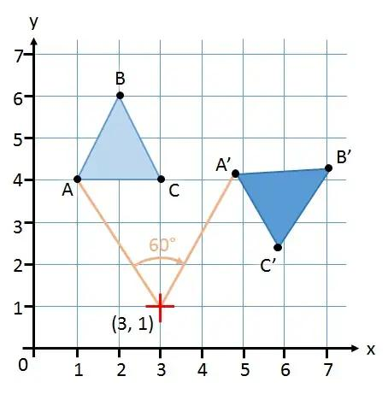
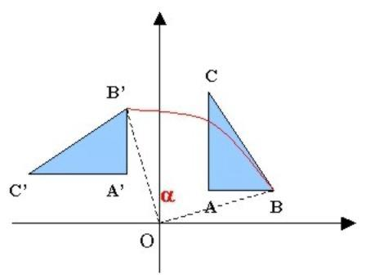
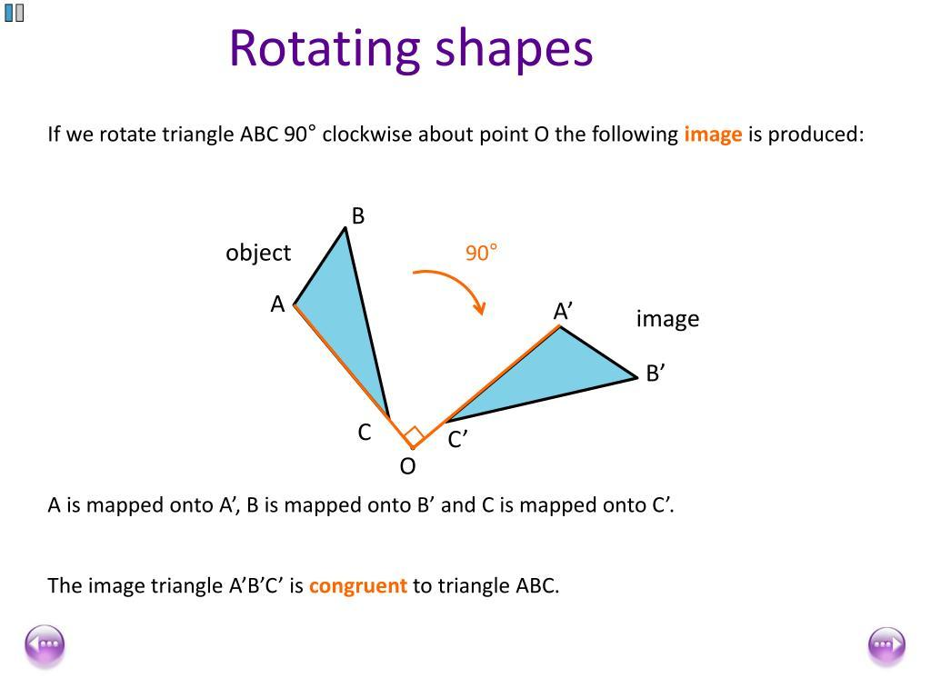
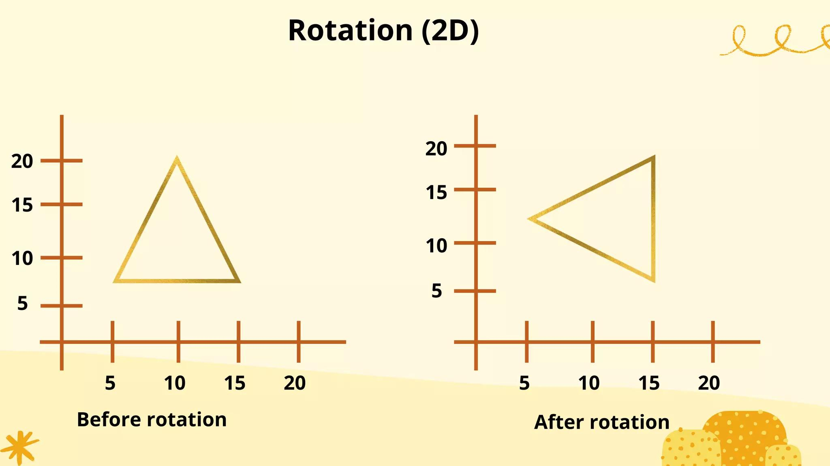

Rotation and Congruence
# Source: AI Source: Provided by: [Data Path: Persons Table -> ID Column: 1, Name_En Column: Motasem Essam] -> From: [ChatGPT] on [7/25/2026]
Because rotation preserves:
- Side lengths
- Angles
- Shape
- Size
- Area
- Perimeter
the original and rotated figures are congruent.
$$\boxed{F≅F^{'}}$$

Rotation and Symmetry
# Source: AI Source: Provided by: [Data Path: Persons Table -> ID Column: 1, Name_En Column: Motasem Essam] -> From: [ChatGPT] on [7/25/2026]
Rotation is closely related to rotational symmetry.
A figure has rotational symmetry if it can be rotated by an angle smaller than ${360}^{∘}$ and still look unchanged.
For example, a square has rotational symmetry at:
$${90}^{∘} \\ {180}^{∘} \\ {270}^{∘}$$
and:
$${360}^{∘}$$
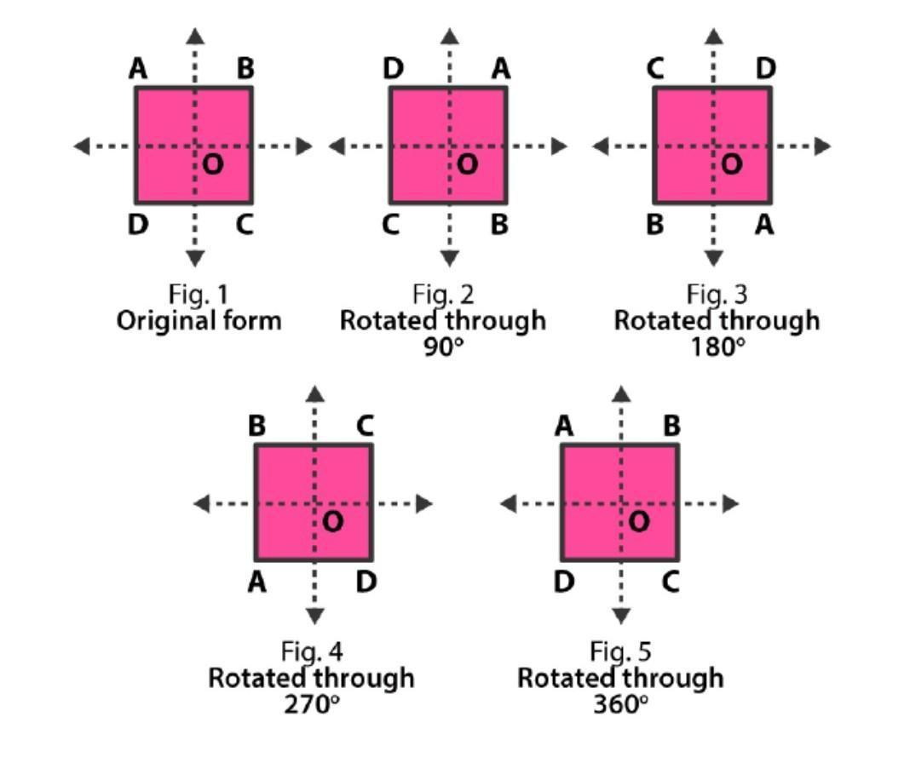
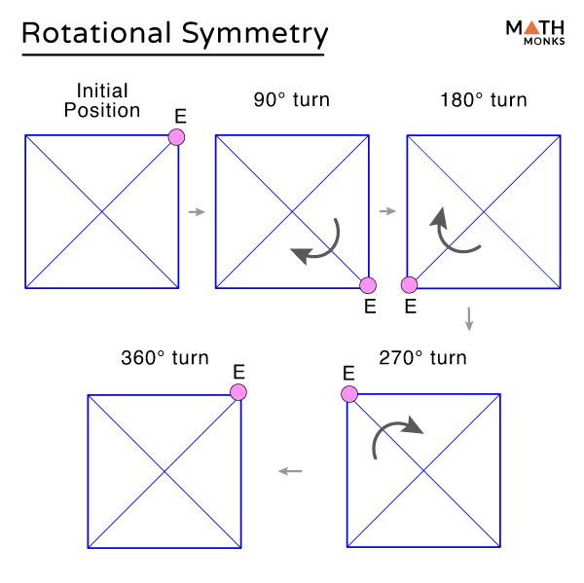
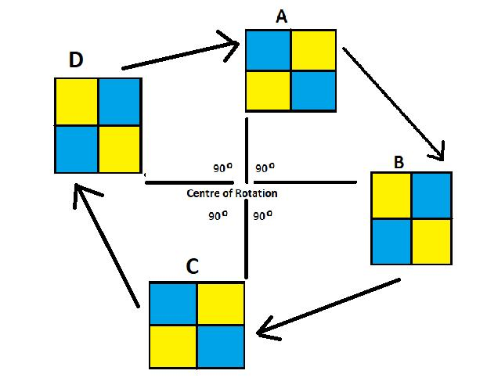
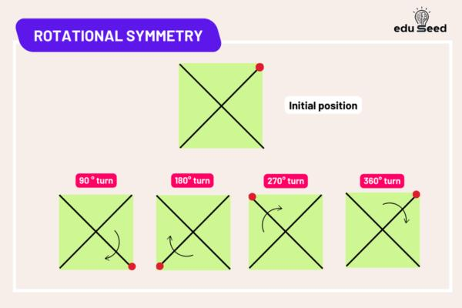
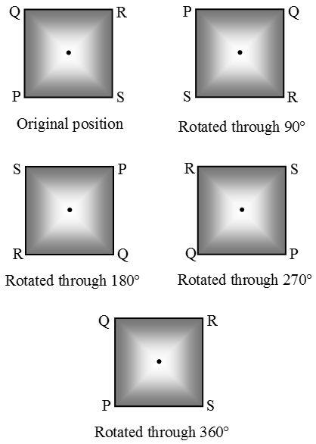

Order of Rotational Symmetry
# Source: AI Source: Provided by: [Data Path: Persons Table -> ID Column: 1, Name_En Column: Motasem Essam] -> From: [ChatGPT] on [7/25/2026]
The order of rotational symmetry is the number of times a figure matches itself during one complete ${360}^{∘}$rotation.
For a square:
$$\boxed{\text{Order}=4}$$
because it matches itself every:
$$\frac{{360}^{∘}}{4}={90}^{∘}$$

Rotation About a Point Other Than the Origin
# Source: AI Source: Provided by: [Data Path: Persons Table -> ID Column: 1, Name_En Column: Motasem Essam] -> From: [ChatGPT] on [7/25/2026]
Rotation does not have to occur around:
$$\left(0 , 0\right)$$
It can occur around any point:
$$\boxed{\left(h , k\right)}$$
For a rotation around a point other than the origin, the general process is:
- Translate the center of rotation to the origin.
- Apply the rotation.
- Translate the figure back.
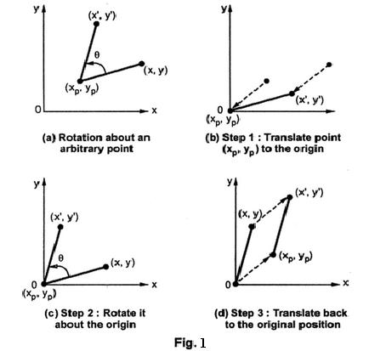
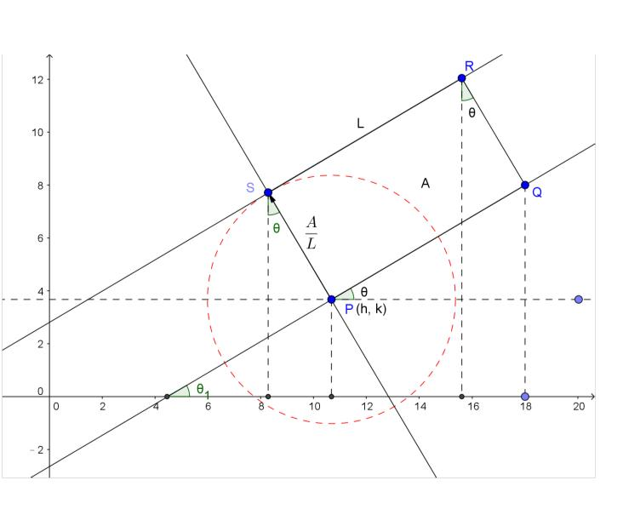
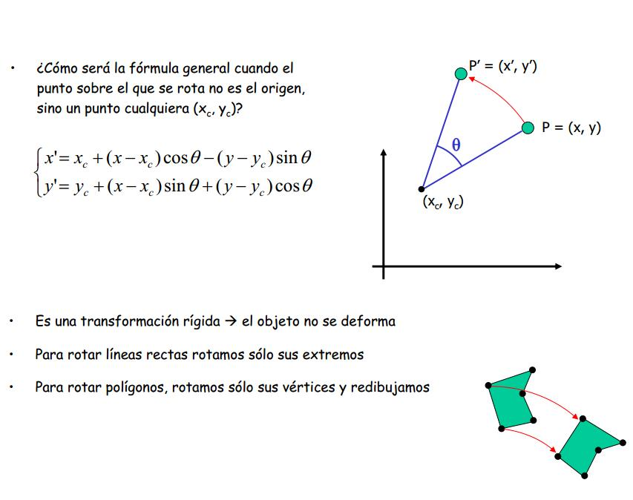

Rotation Around the Origin vs. Another Point
# Source: AI Source: Provided by: [Data Path: Persons Table -> ID Column: 1, Name_En Column: Motasem Essam] -> From: [ChatGPT] on [7/25/2026]
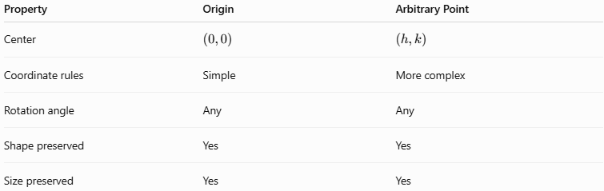
Property | Origin | Arbitrary Point
Center | $$\left(0 , 0\right)$$ | $$\left(h , k\right)$$
Coordinate rules | Simple | More complex
Rotation angle | Any | Any
Shape preserved | Yes | Yes
Size preserved | Yes | Yes

General Rotation Formula
# Source: AI Source: Provided by: [Data Path: Persons Table -> ID Column: 1, Name_En Column: Motasem Essam] -> From: [ChatGPT] on [7/25/2026]
For a counterclockwise rotation by angle $θ$ about the origin:
$$\boxed{x^{'}=x\cos{θ}-y\sin{θ}} \\ \boxed{y^{'}=x\sin{θ}+y\cos{θ}}$$
Therefore:
$$\boxed{\left(x , y\right)→\left(x , \cos{θ}-y\sin{θ} x\sin{θ}+y\cos{θ}\right)}$$

Matrix Representation
# Source: AI Source: Provided by: [Data Path: Persons Table -> ID Column: 1, Name_En Column: Motasem Essam] -> From: [ChatGPT] on [7/25/2026]
Rotation can also be represented using a matrix:
$$\boxed{\left(\begin{matrix}x^{'} \\ y^{'}\end{matrix}\right)=\left(\begin{matrix}\cos{θ} & -\sin{θ} \\ \sin{θ} & \cos{θ}\end{matrix}\right)\left(\begin{matrix}x \\ y\end{matrix}\right)}$$
This representation is particularly useful in:
- Coordinate geometry
- Linear algebra
- Computer graphics
- Robotics
- Engineering

Composition of Rotations
# Source: AI Source: Provided by: [Data Path: Persons Table -> ID Column: 1, Name_En Column: Motasem Essam] -> From: [ChatGPT] on [7/25/2026]
Multiple rotations can be performed one after another.
For example:
$${90}^{∘}+{90}^{∘}={180}^{∘}$$
Therefore, two consecutive ${90}^{∘}$ counterclockwise rotations about the same center are equivalent to one ${180}^{∘}$ counterclockwise rotation.
$$\boxed{R_{{90}^{∘}}∘R_{{90}^{∘}}=R_{{180}^{∘}}}$$

Rotation of a Circle
# Source: AI Source: Provided by: [Data Path: Persons Table -> ID Column: 1, Name_En Column: Motasem Essam] -> From: [ChatGPT] on [7/25/2026]
When a circle is rotated around its center, the circle appears unchanged.
If:
$$O=\left(0 , 0\right)$$
and:
$$r=5$$
then rotating the circle about $O$ preserves:
$$\boxed{r=5}$$
and its entire shape.
If the center of rotation is different from the circle's center, the circle itself moves to a new position while maintaining the same radius.
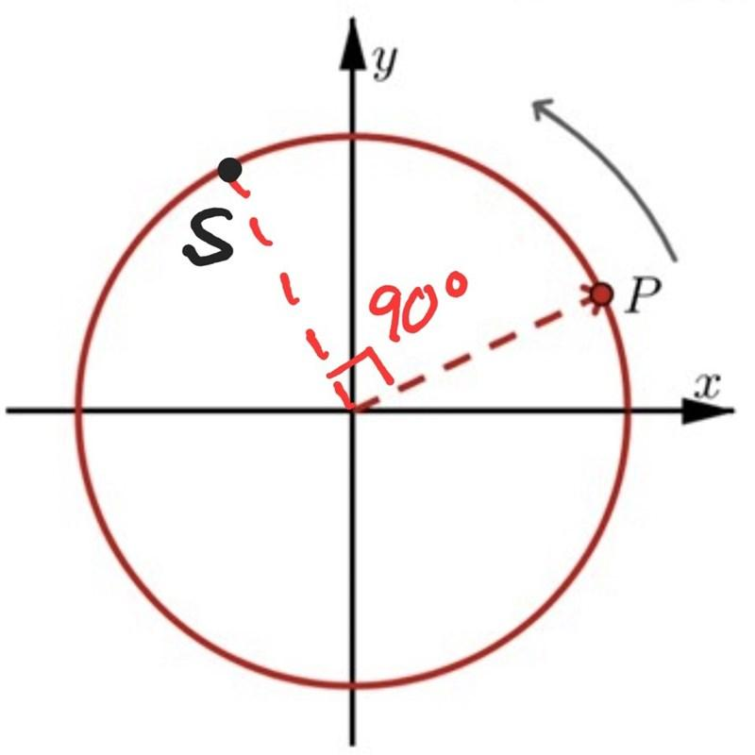
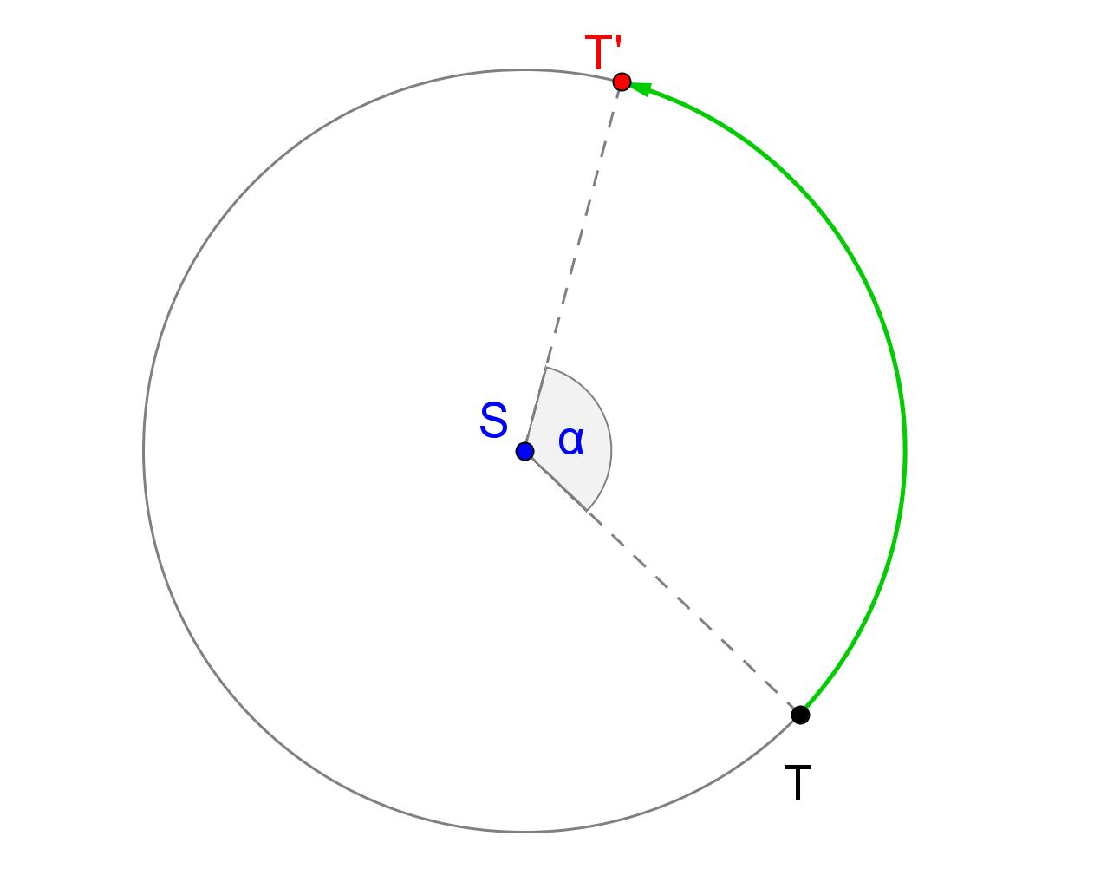
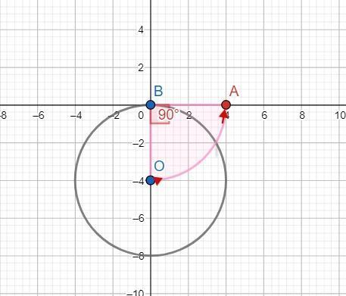
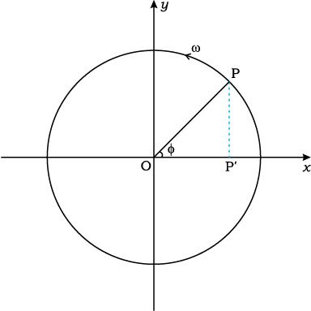

Rotation in Computer Graphics
# Source: AI Source: Provided by: [Data Path: Persons Table -> ID Column: 1, Name_En Column: Motasem Essam] -> From: [ChatGPT] on [7/25/2026]
Computer graphics use rotation to change the orientation of objects.
For a point:
$$\left(x , y\right)$$
rotation by $θ$ uses:
$$\boxed{\left(x^{'} , y^{'}\right)=\left(x , \cos{θ}-y\sin{θ} x\sin{θ}+y\cos{θ}\right)}$$
Applications include:
- Rotating game characters.
- Rotating images.
- Rotating 2D objects.
- Animation.
- CAD.
- Computer-aided design.
- Robotics.
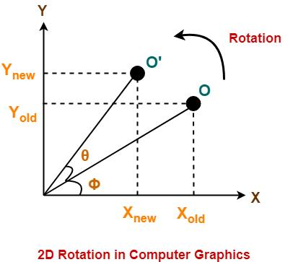
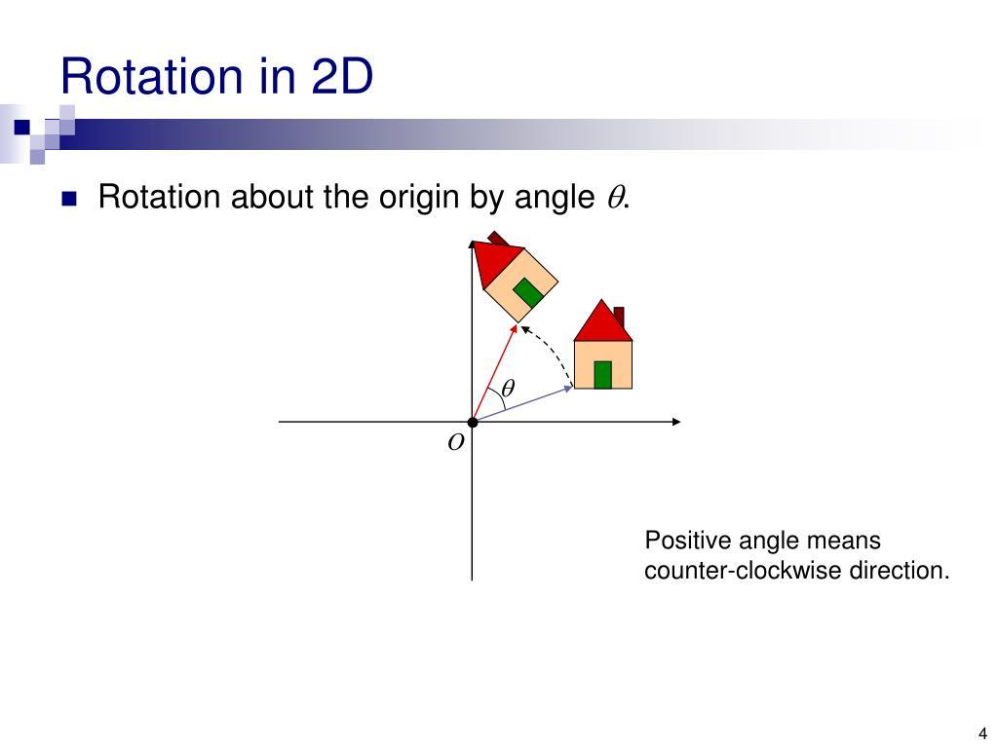
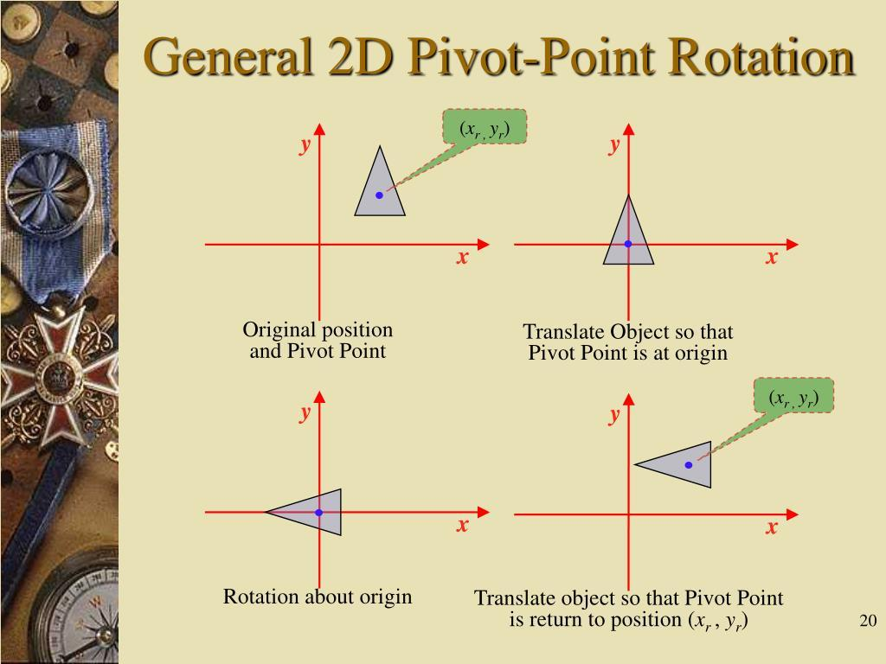
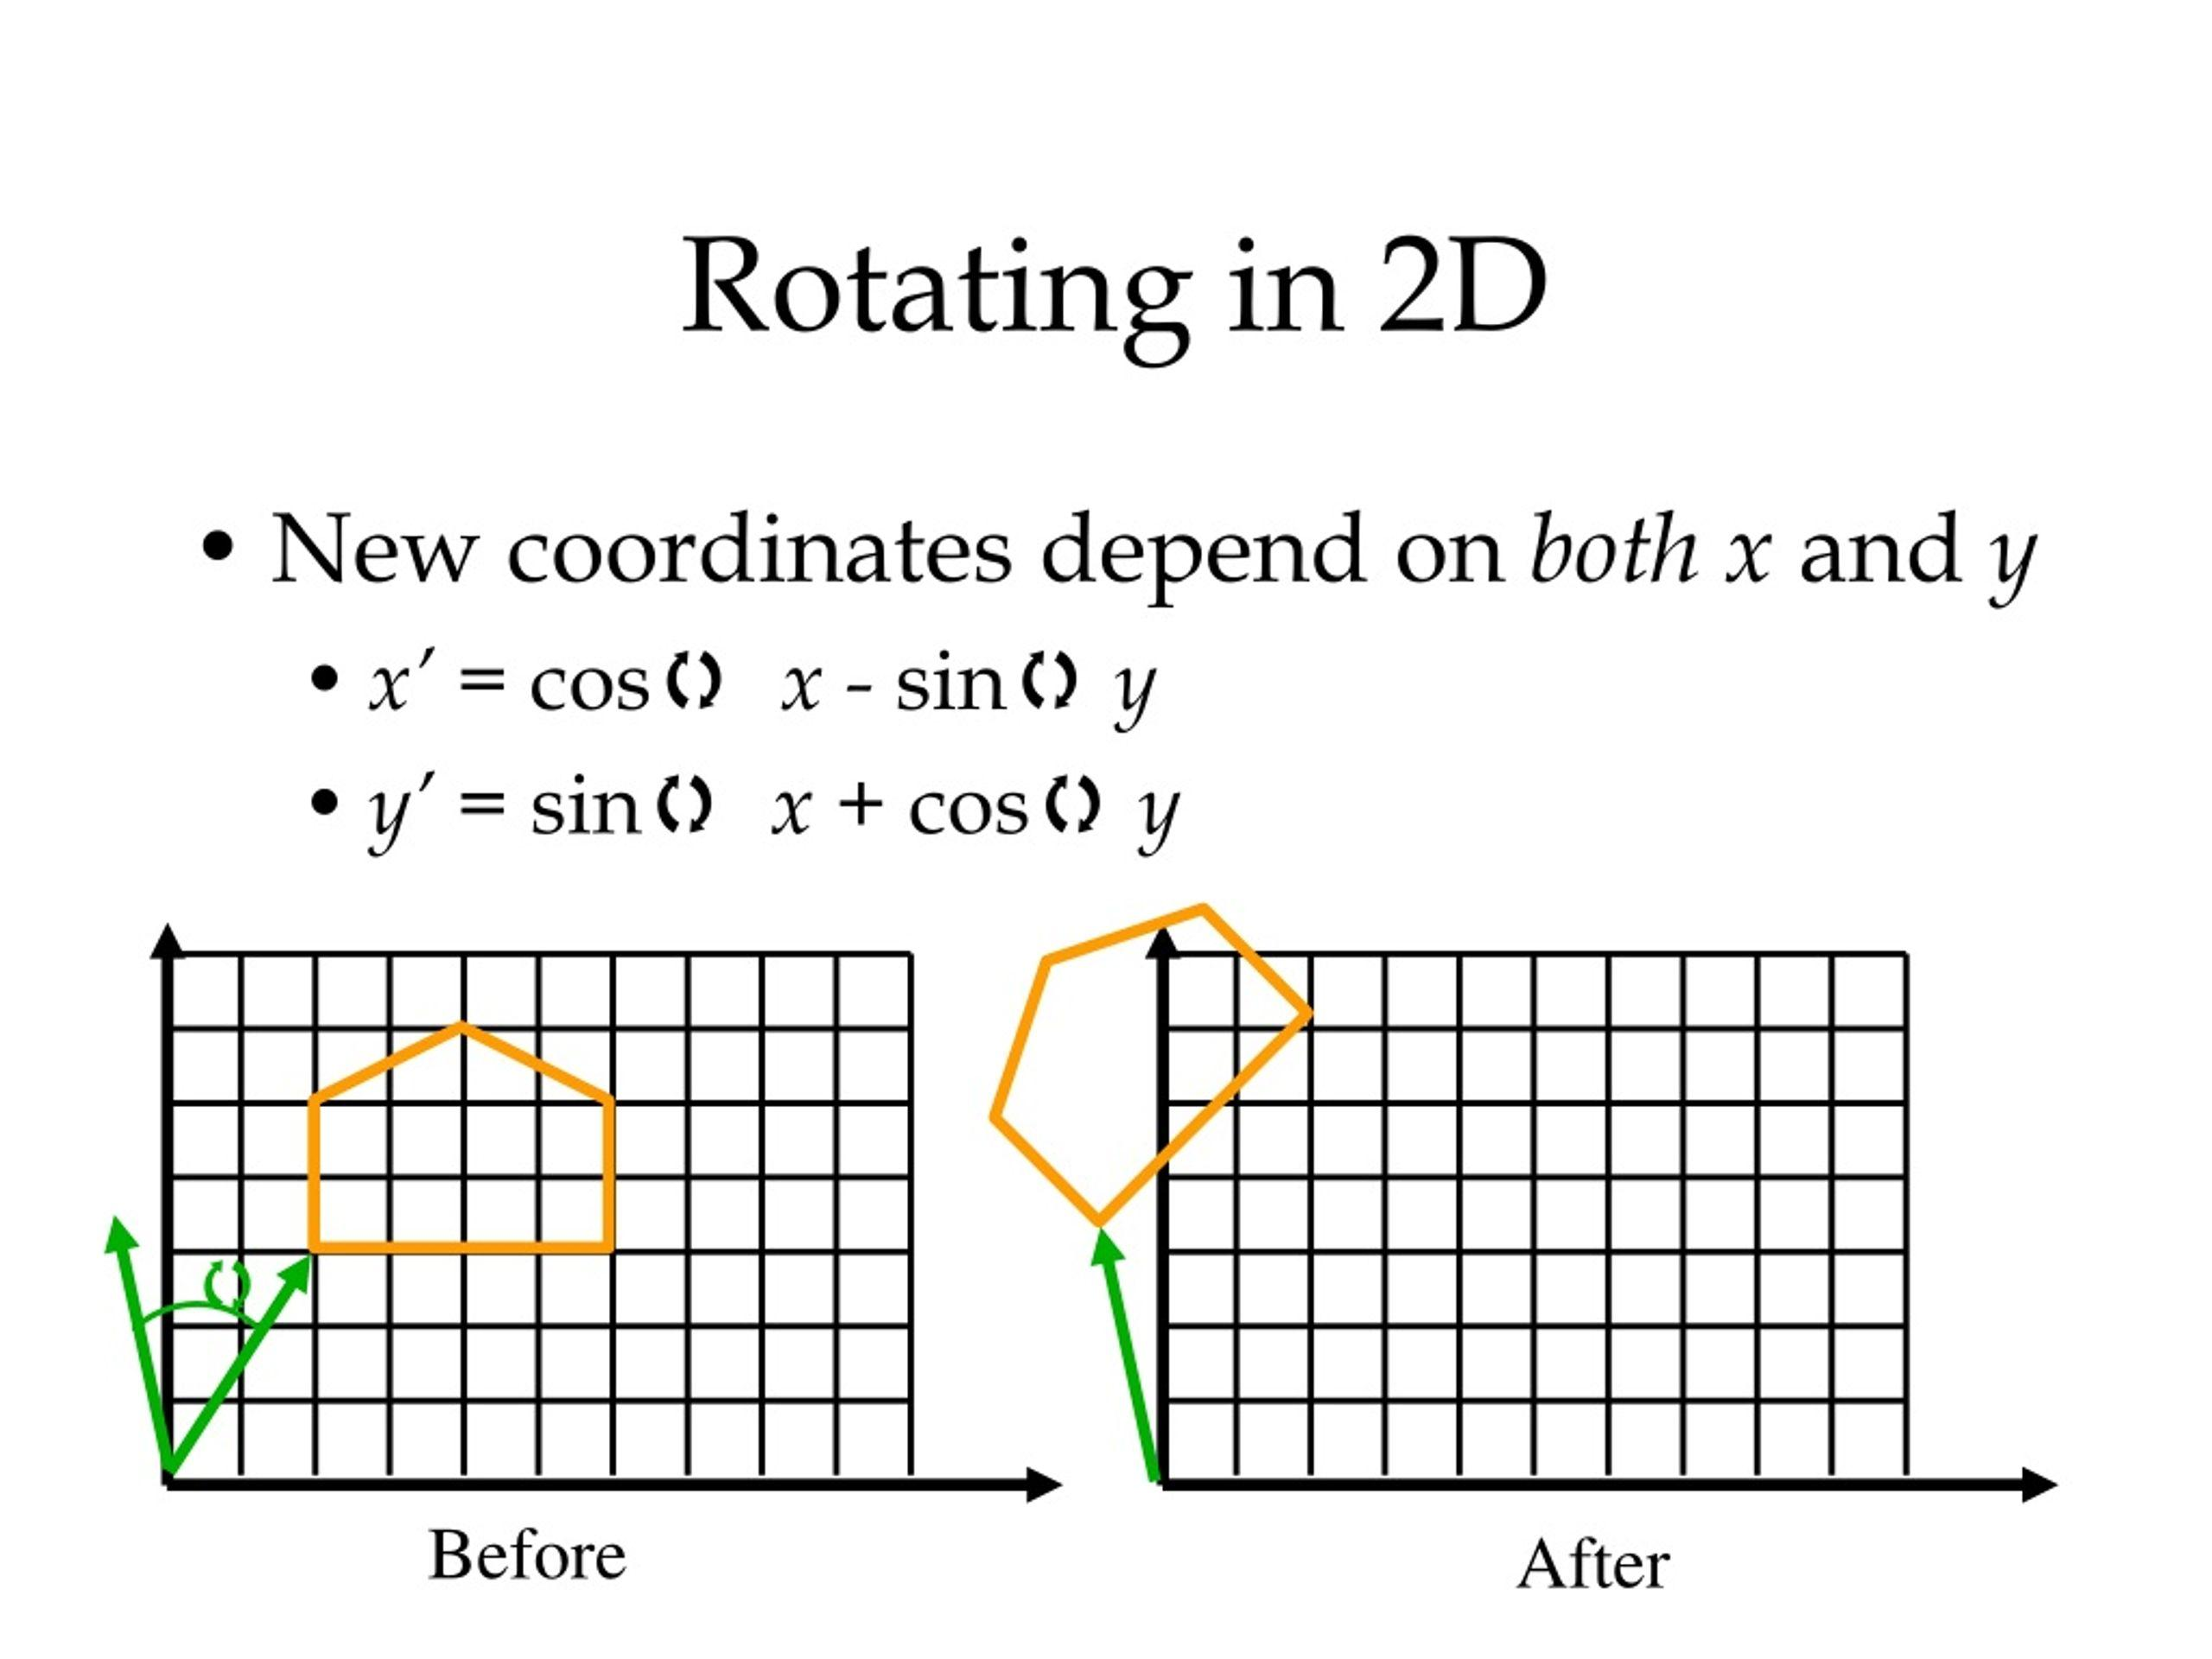
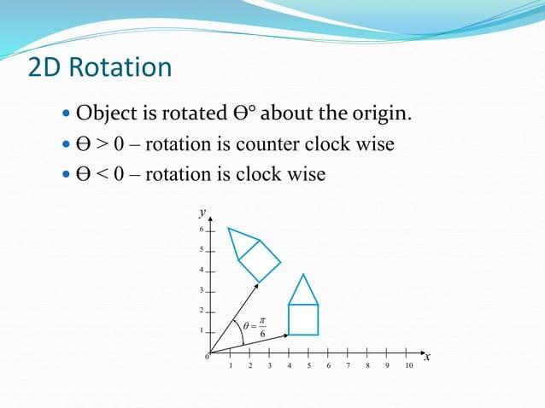

Rotation in Robotics
# Source: AI Source: Provided by: [Data Path: Persons Table -> ID Column: 1, Name_En Column: Motasem Essam] -> From: [ChatGPT] on [7/25/2026]
Robotic arms and joints frequently rotate around fixed axes or points.
Geometrically, the position of a component can be modeled using rotations.
Rotation is essential for describing:
- Robot orientation.
- Joint movement.
- Tool positioning.
- Motion planning.
- Coordinate transformations.
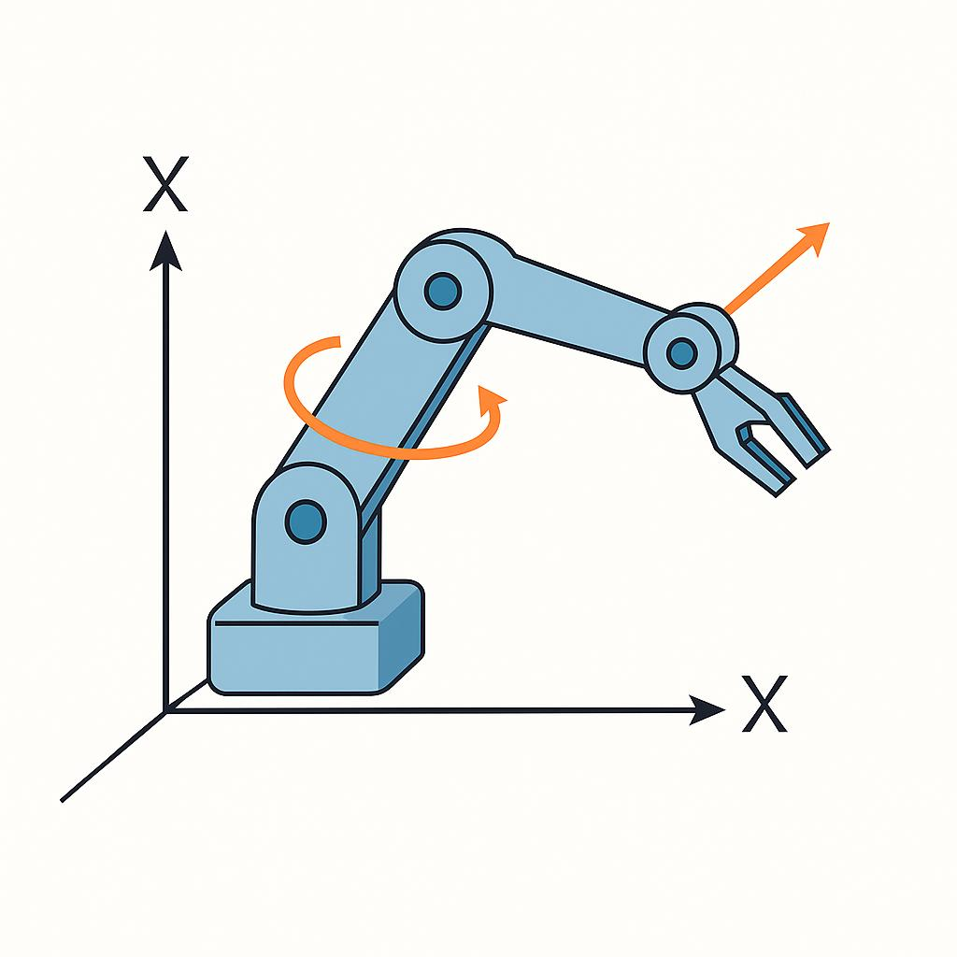
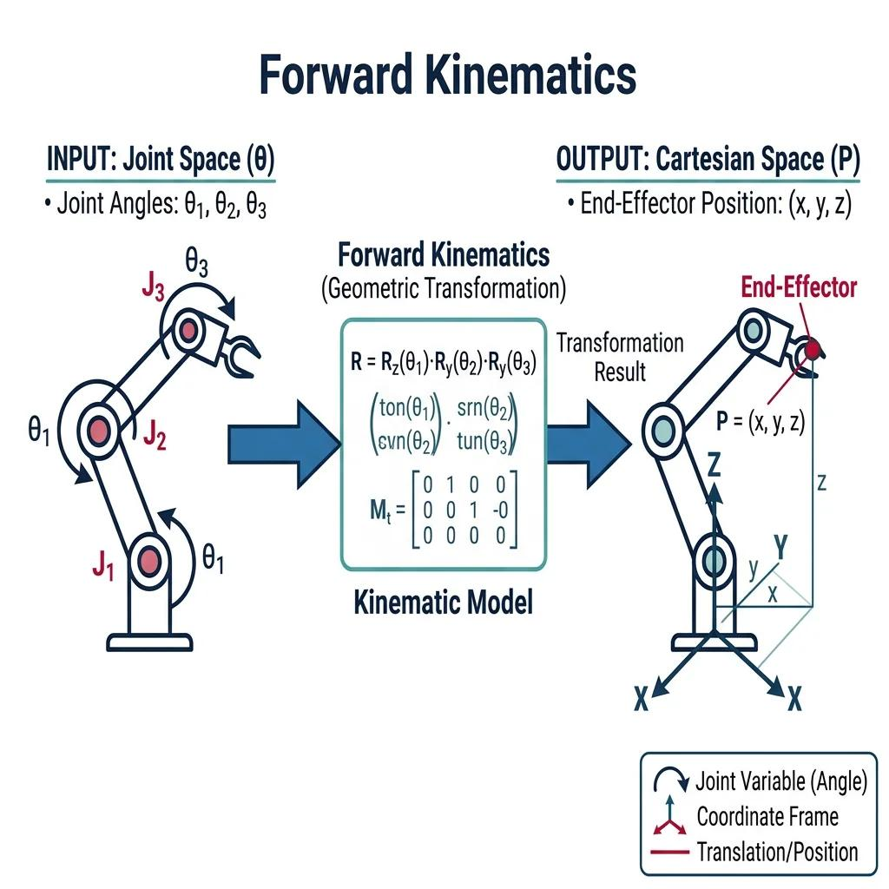
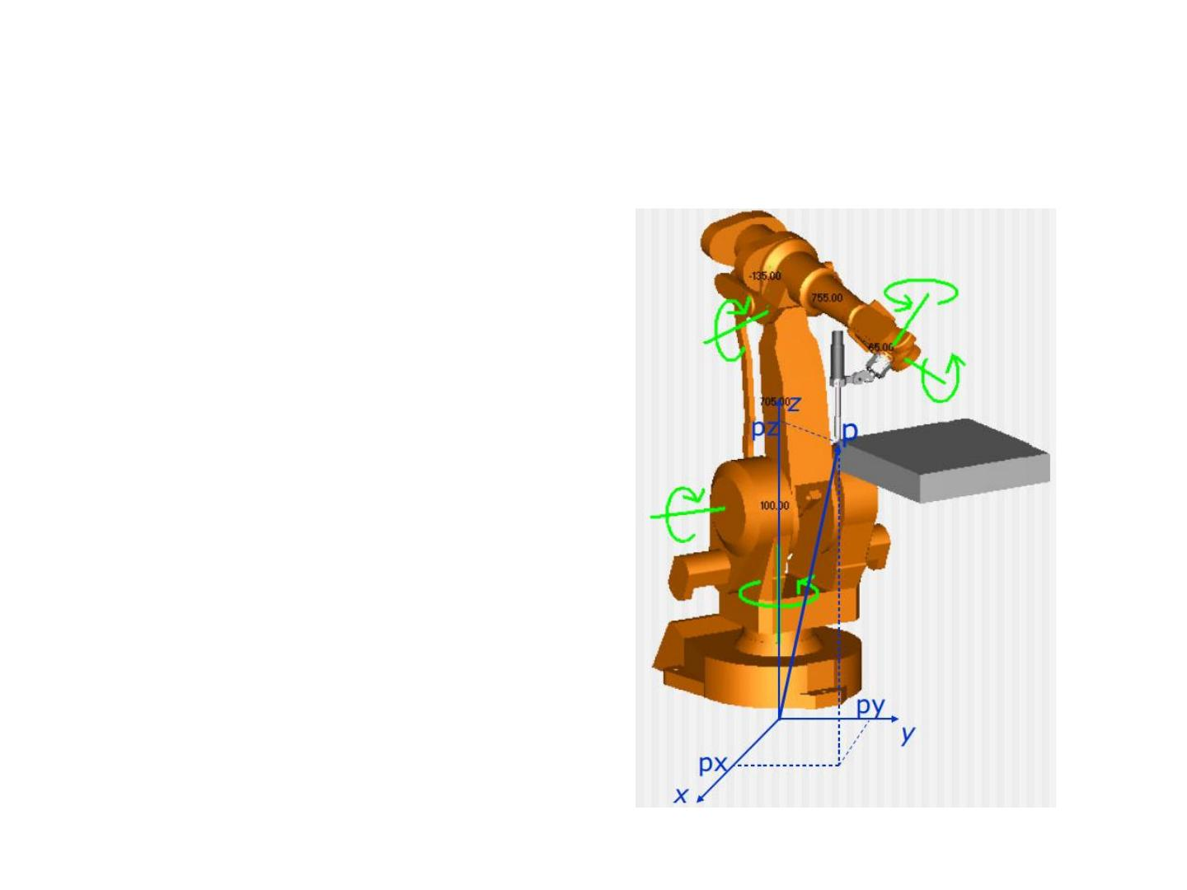
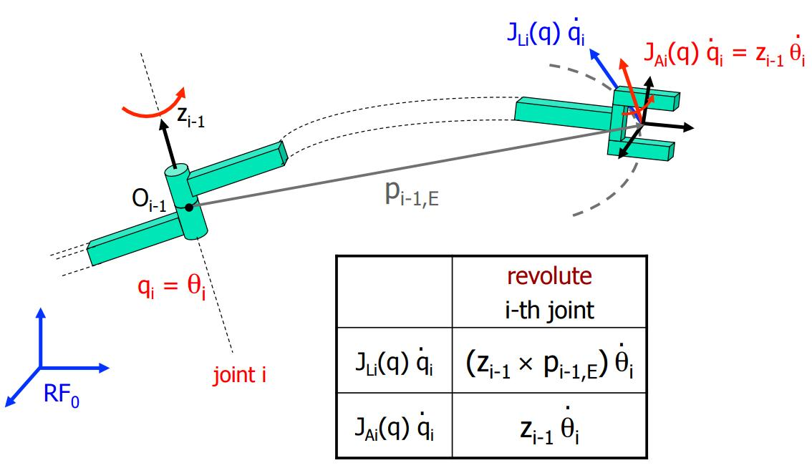

Rotation in CAD
# Source: AI Source: Provided by: [Data Path: Persons Table -> ID Column: 1, Name_En Column: Motasem Essam] -> From: [ChatGPT] on [7/25/2026]
CAD systems use rotation to change the orientation of geometric objects.
A designer can rotate:
- Lines
- Circles
- Polygons
- Components
- Mechanical parts
- Architectural elements
while preserving their dimensions.

Real-World Examples
# Source: AI Source: Provided by: [Data Path: Persons Table -> ID Column: 1, Name_En Column: Motasem Essam] -> From: [ChatGPT] on [7/25/2026]
Rotation can model:
- Clock hands.
- Wheels turning around an axle.
- Gears.
- Ferris wheels.
- Rotating doors.
- Fans.
- Mechanical joints.
- Robot arms.
- Spinning objects.
- Rotating components in machines.
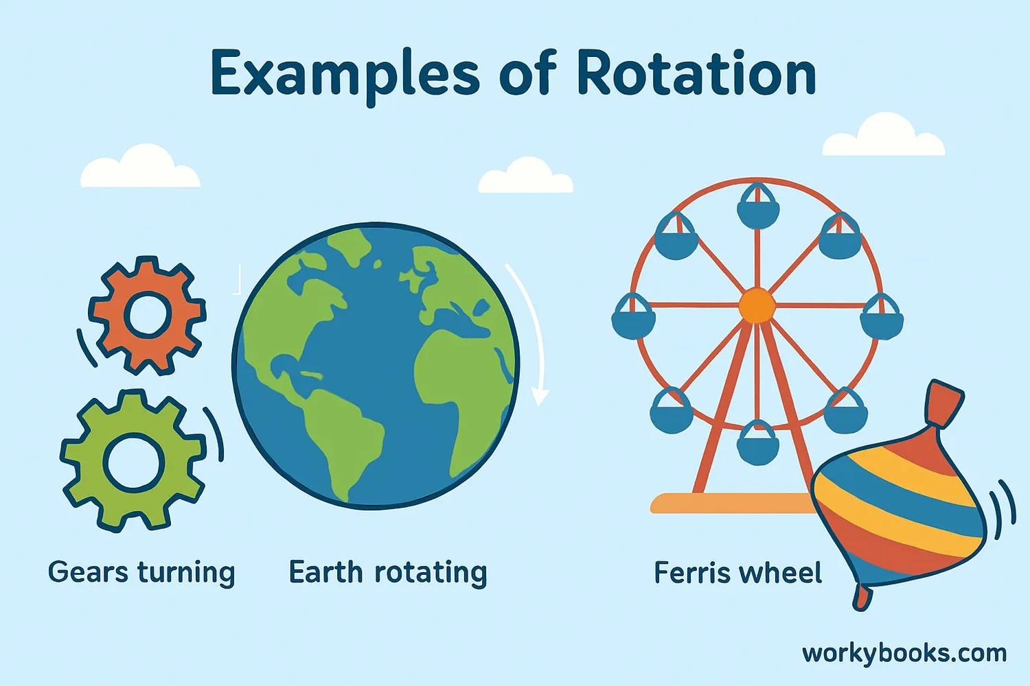

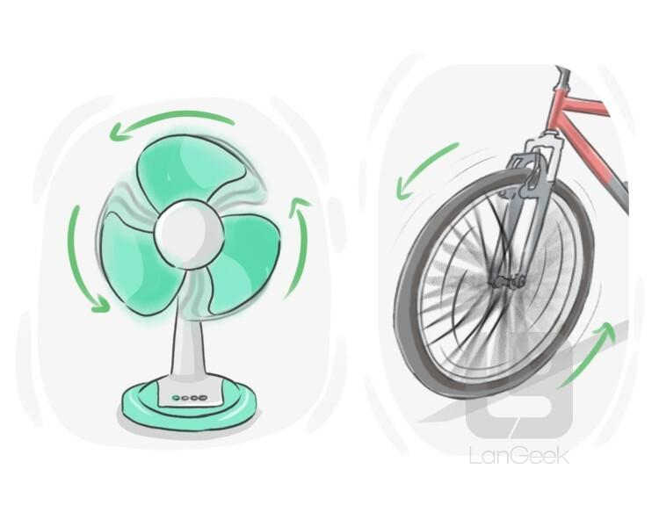
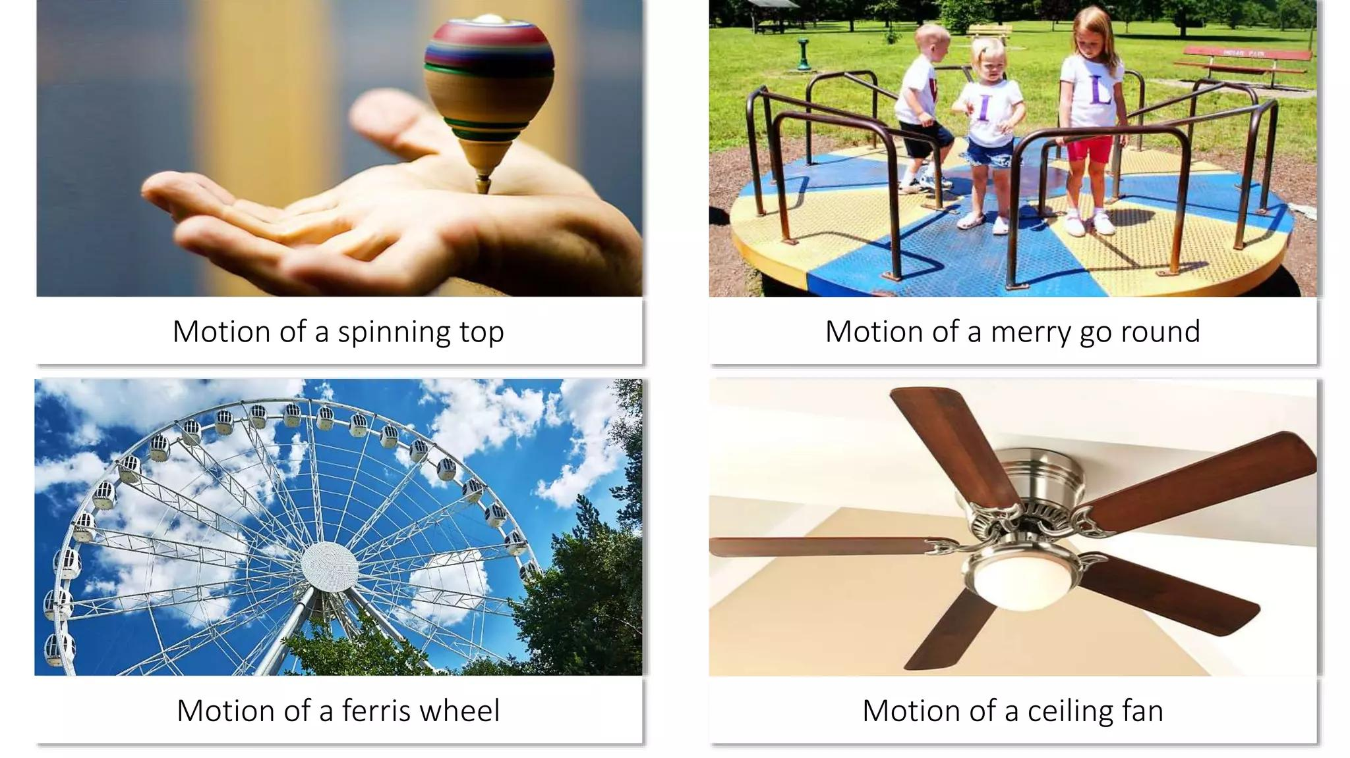
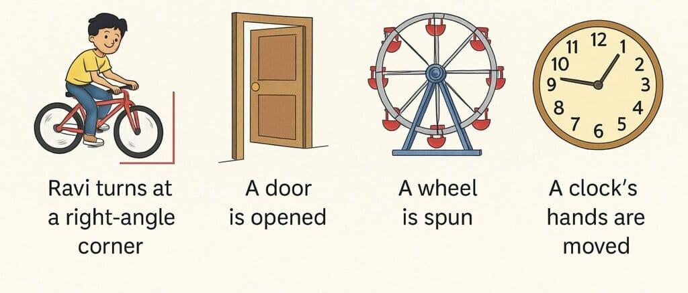
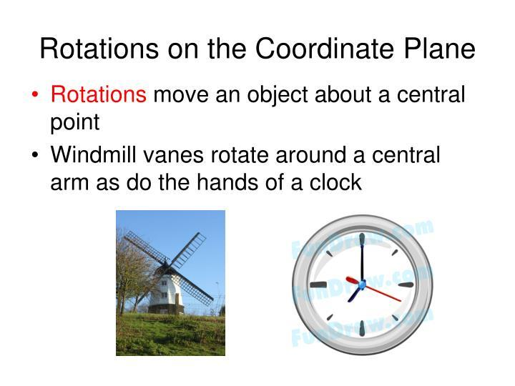

Advantages
# Source: AI Source: Provided by: [Data Path: Persons Table -> ID Column: 1, Name_En Column: Motasem Essam] -> From: [ChatGPT] on [7/25/2026]
Studying rotation helps to:
- Understand geometric transformations.
- Analyze rotational movement.
- Work with coordinate geometry.
- Understand angles and vectors.
- Study rotational symmetry.
- Create geometric patterns.
- Model mechanical motion.
- Develop computer graphics.
- Support CAD and robotics.

Limitations
# Source: AI Source: Provided by: [Data Path: Persons Table -> ID Column: 1, Name_En Column: Motasem Essam] -> From: [ChatGPT] on [7/25/2026]
Rotation:
- Changes the position and orientation of a figure.
- Requires a defined center of rotation.
- Requires an angle of rotation.
- Requires a direction when using signed angles.
- Does not change size or shape.
- Can require more complex calculations when the center is not the origin.

Comparison with Other Transformations
# Source: AI Source: Provided by: [Data Path: Persons Table -> ID Column: 1, Name_En Column: Motasem Essam] -> From: [ChatGPT] on [7/25/2026]
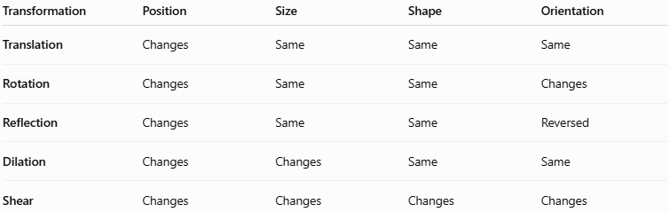
Transformation | Position | Size | Shape | Orientation
Translation | Changes | Same | Same | Same
Rotation | Changes | Same | Same | Changes
Reflection | Changes | Same | Same | Reversed
Dilation | Changes | Changes | Same | Same
Shear | Changes | Changes | Changes | Changes
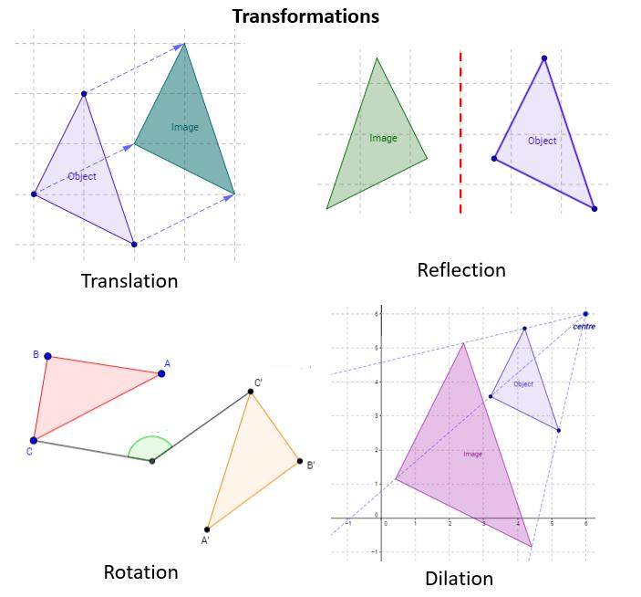
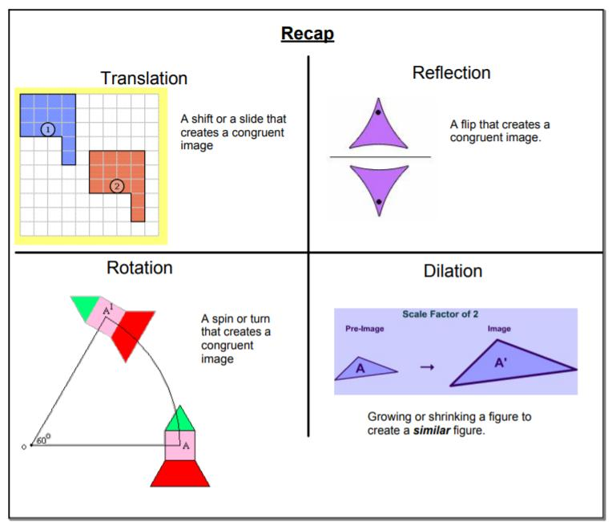
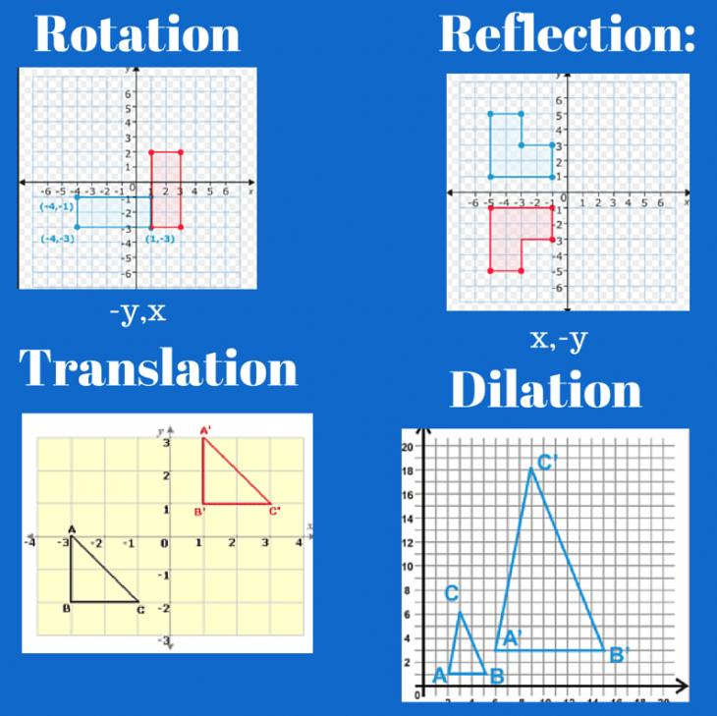
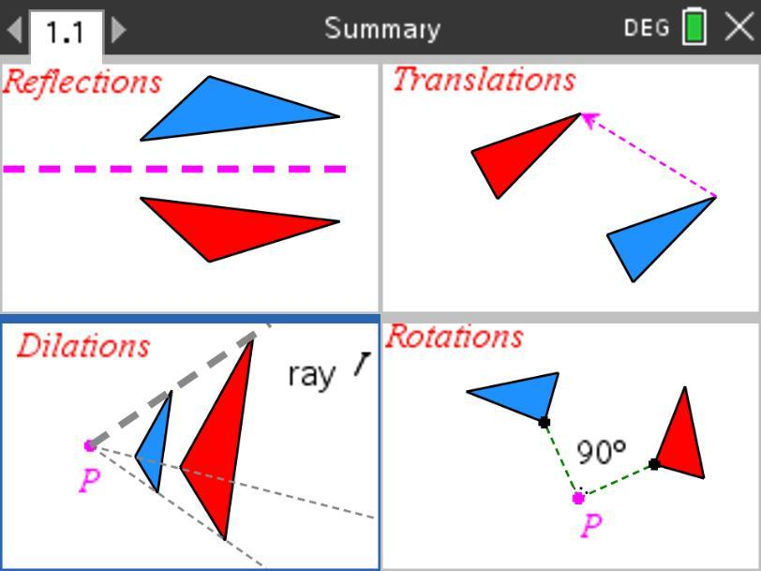
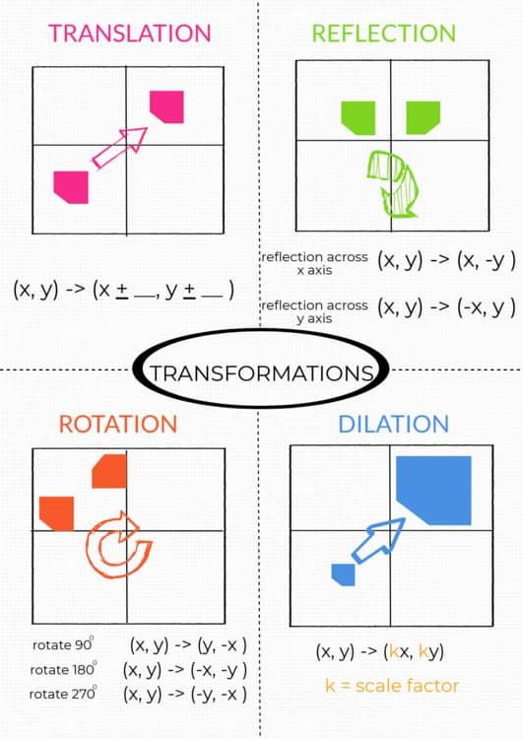

Key Points
# Source: AI Source: Provided by: [Data Path: Persons Table -> ID Column: 1, Name_En Column: Motasem Essam] -> From: [ChatGPT] on [7/25/2026]
- Rotation turns a figure around a fixed point.
- The fixed point is called the center of rotation.
- The amount of turning is the angle of rotation.
- Rotation can be clockwise or counterclockwise.
- Every point rotates through the same angle.
- The distance from each point to the center of rotation remains constant:
$$\boxed{OA=OA^{'}}$$
- Rotation preserves:
  - Shape
  - Size
  - Side lengths
  - Angles
  - Area
  - Perimeter
- Rotation changes the position and orientation of a figure.
- A rotation is a rigid transformation.
- A rotation by ${360}^{∘}$ returns the figure to its original position.
Important coordinate rules about the origin
$$\boxed{{90}^{∘}\text{ CCW}:\left(x , y\right)→\left(- , yx\right)} \\ \boxed{{180}^{∘}:\left(x , y\right)→\left(- , x-y\right)} \\ \boxed{{270}^{∘}\text{ CCW}:\left(x , y\right)→\left(y , -x\right)} \\ \boxed{{360}^{∘}:\left(x , y\right)→\left(x , y\right)}$$

Conclusion
# Source: AI Source: Provided by: [Data Path: Persons Table -> ID Column: 1, Name_En Column: Motasem Essam] -> From: [ChatGPT] on [7/25/2026]
Rotation is a fundamental type of geometric transformation in which a figure is turned around a fixed center of rotation through a specified angle and direction. Unlike translation, rotation changes the orientation of a figure, but it preserves its shape, size, side lengths, angles, area, and perimeter. For rotation about the origin, the general coordinate transformation is:
$$\boxed{\left(x , y\right)→\left(x , \cos{θ}-y\sin{θ} x\sin{θ}+y\cos{θ}\right)}$$
Rotation is fundamental to plane geometry, coordinate geometry, rotational symmetry, trigonometry, computer graphics, CAD, engineering, robotics, animation, and mechanical design.

